Assignment 1
MSS301 – Cinema Ticket Booking System using API Gateway
Created by: traltb@fe.edu.vn
Link github: https://github.com/lengocdang1

Mục lục

1. F0 – Hạ tầng và khởi tạo project 3
1.1. TODO 0.1 Tạo thư mục gốc 3
1.2. TODO 0.2 mysql/init.sql tạo 3 database cinema_customer, cinema_movie, cinema_booking 3
1.3. TODO 0.3 3
1.4. TODO 0.4 3
2. F1- Authentication (customer-service + Gateway) 3
2.1. TODO 2.1 Flyway V1__init.sql (bảng customer) + V2__seed.sql (3 customer mẫu, 1 INACTIVE) 3
2.2. Tiếp tục các phần F11 – Kiểm thử Postman. 3

F0 – Hạ tầng và khởi tạo project

TODO 0.1 Tạo thư mục gốc
- Chụp hình kết quả: cấu trúc project/ kết quả chạy / output terminal
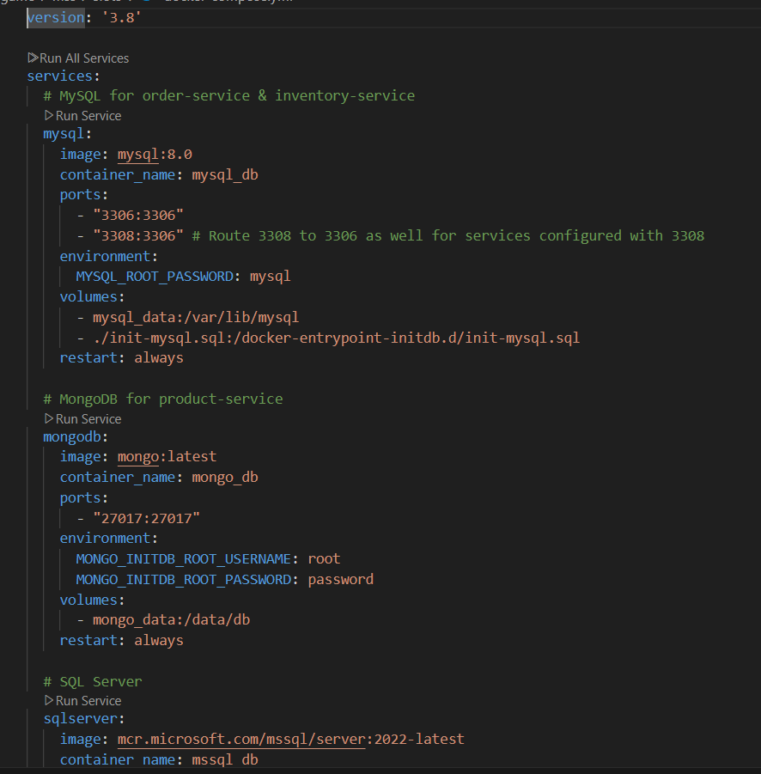
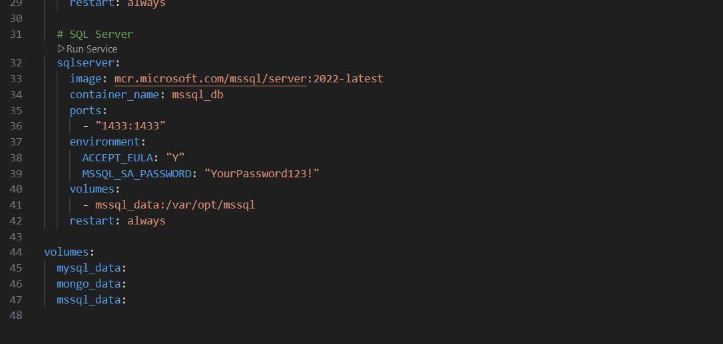
- Commit: chore(infra): add docker compose for sql server, mongodb and mysql`
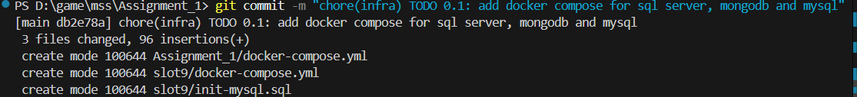

(Coi ở mục 9.4 Bảng commit trong file Assignment1_Guide.md)

TODO 0.2 mysql/init.sql tạo 3 database cinema_customer, cinema_movie, cinema_booking
- Chụp hình kết quả: cấu trúc project/ kết quả chạy / output terminal
- 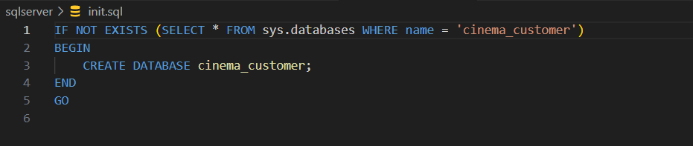
- 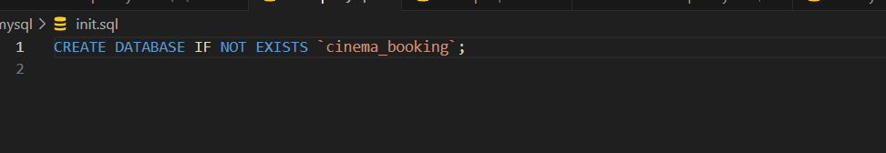
- Commit: chore(infra): add docker compose for sql server, mongodb and mysql`
- 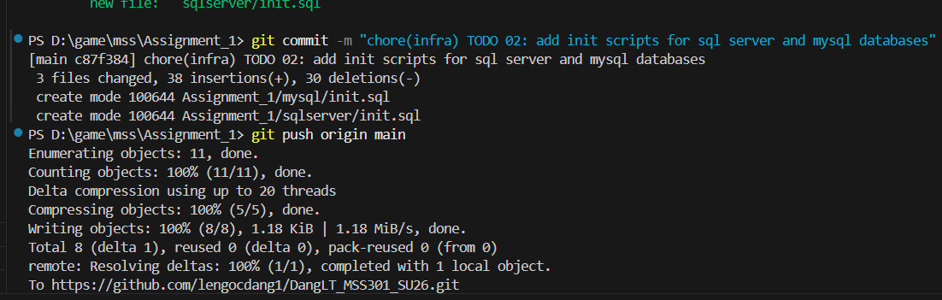
(Coi ở mục 9.4 Bảng commit trong file Assignment1_Guide.md)

TODO 0.3

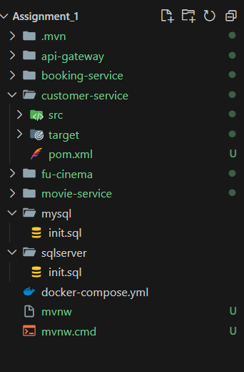
- Commit: build(customer): bootstrap customer-service with sql server driver and flyway`
- Commit: build(movie): bootstrap movie-service with spring data mongodb`
- Commit: build(booking): bootstrap booking-service with mysql and flyway`

TODO 1

Commit : feat(customer): add t-sql migrations with nvarchar and unicode seed data"

1.5 TODO1.1

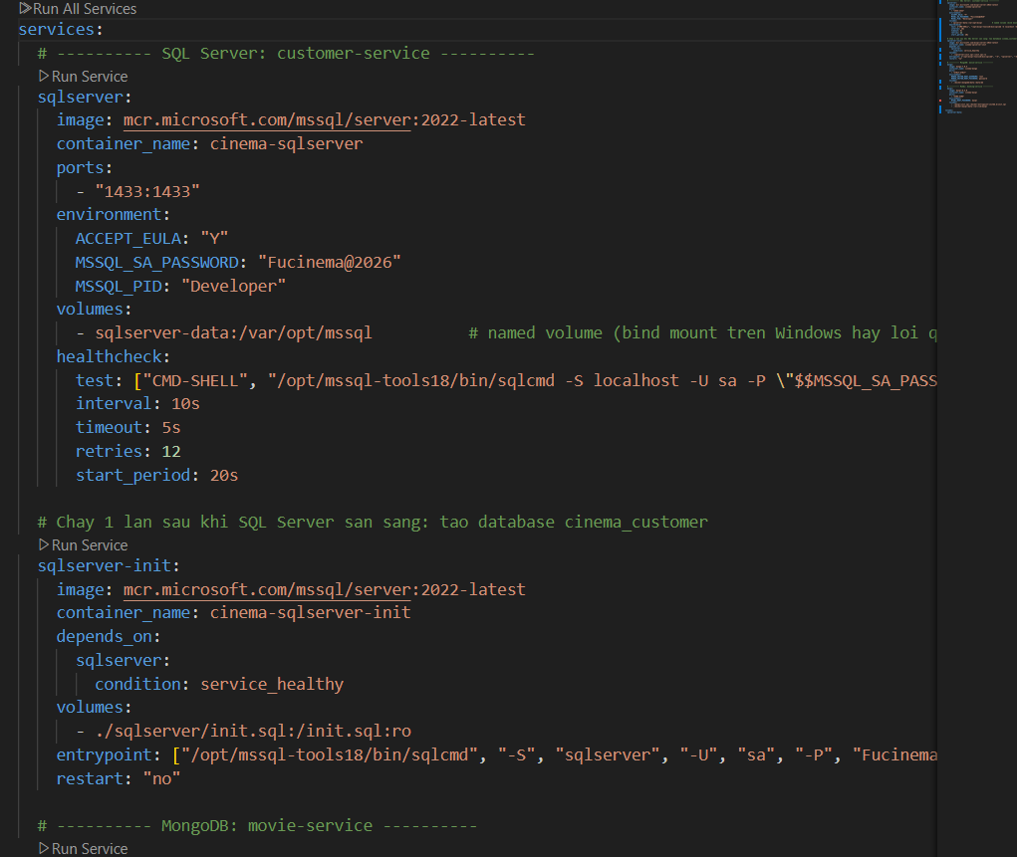

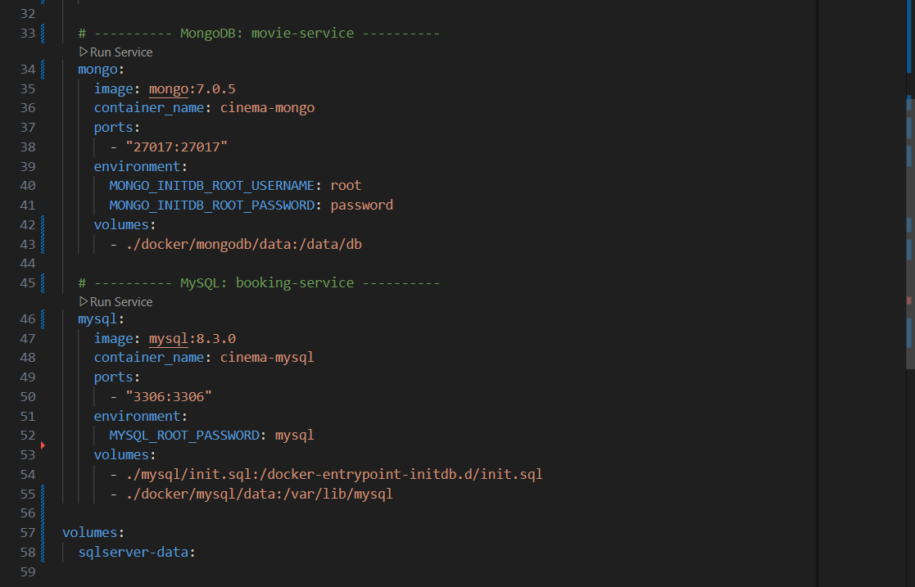

Commit: chore(customer): configure admin account and jwt properties

1.6 TODO0.1

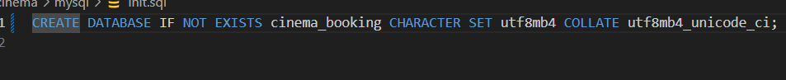

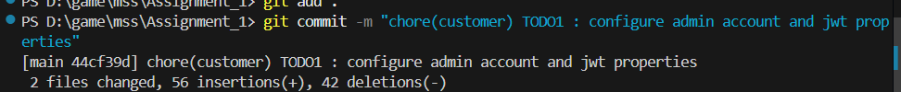

1.7 TODO 0.2

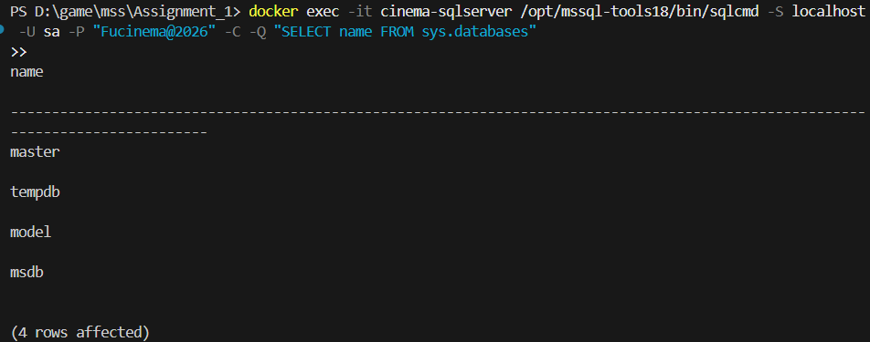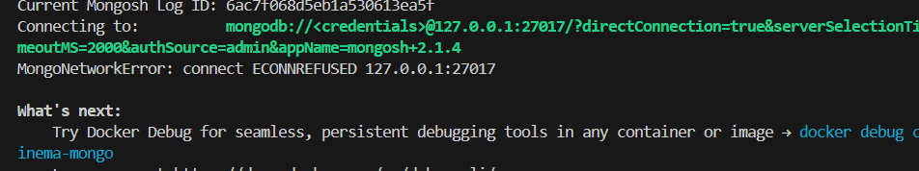

Commit : feat(customer): add bcrypt password encoder bean

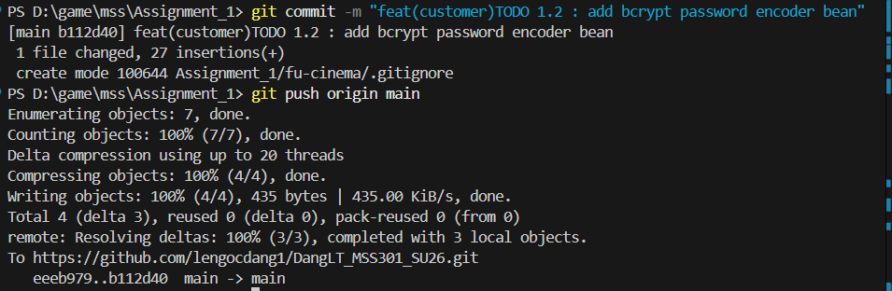

1.7 TODO 0.3

Commit : build(customer): bootstrap customer-service with sql server driver and flyway

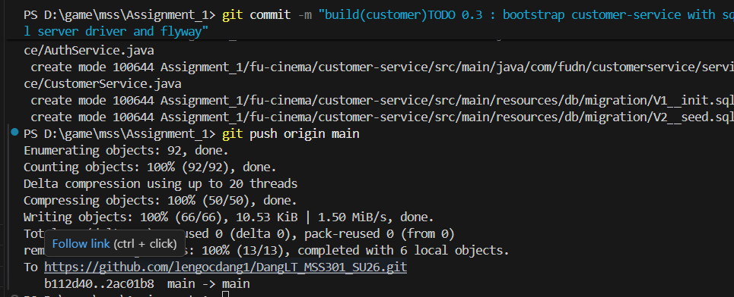

1.8 TODO 0.5 - 1.1

Commit : chore(customer): configure sql server datasource and jpa settings`
chore(movie): configure mongodb connection uri and auto index creation`
chore(booking): configure port, datasource and movie service url`

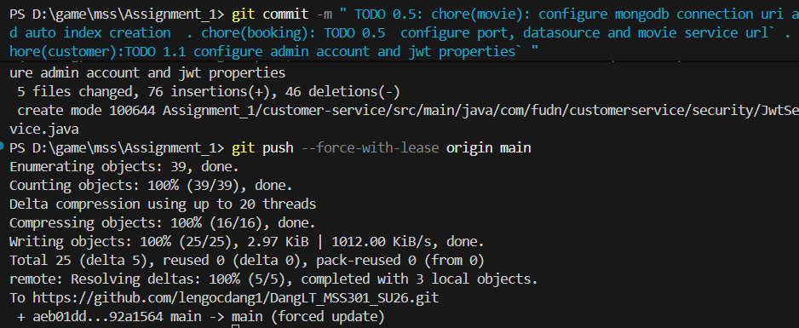

1.9 TODO 0.6
Commit : feat(customer): add global exception handler with unified error body` |
feat(movie): add global exception handler with unified error body` |
feat(booking): add global exception handler with unified error body` |

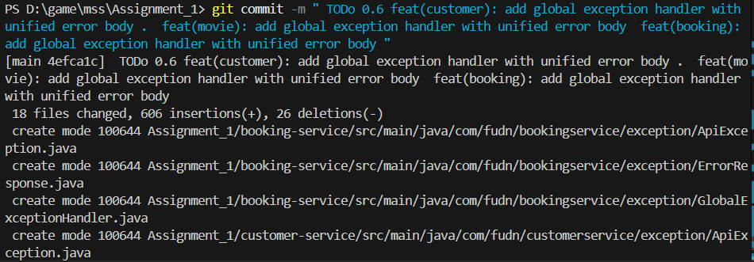

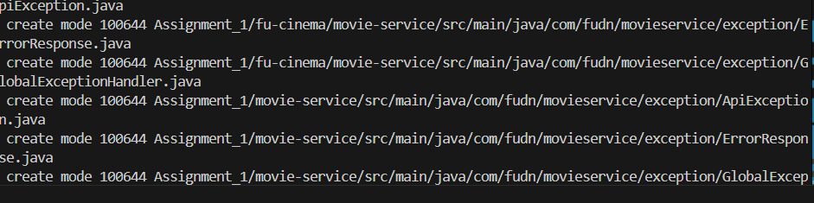

2.0 TODO 2.2

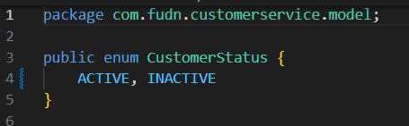

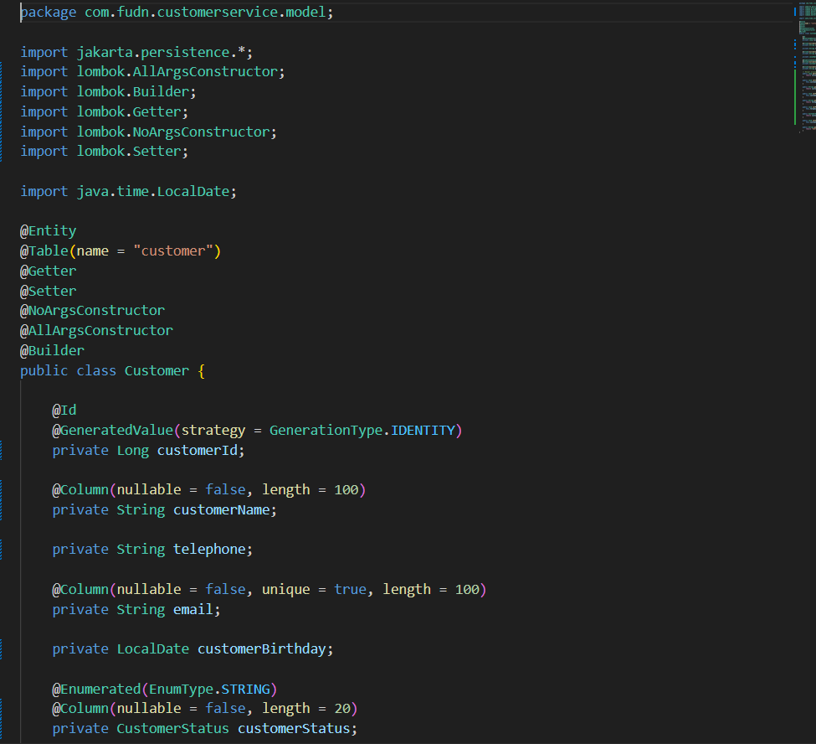

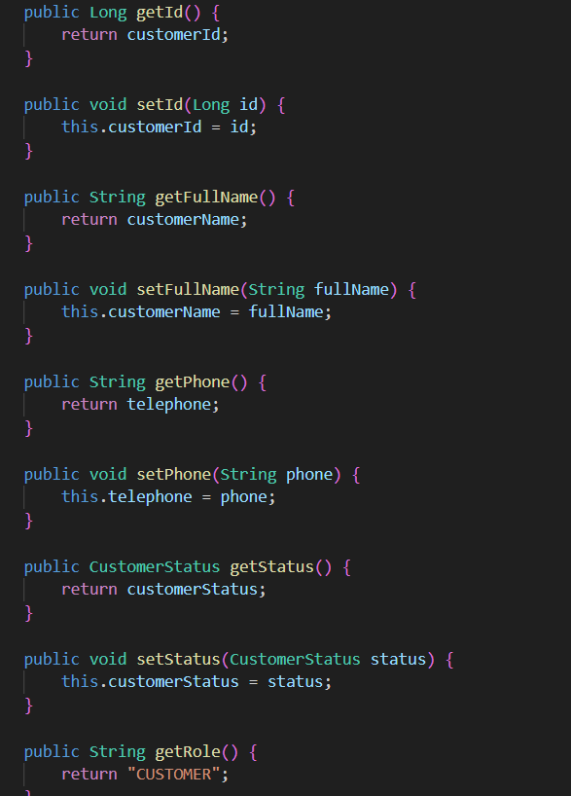
Commit : feat(customer): add Customer entity and repository`
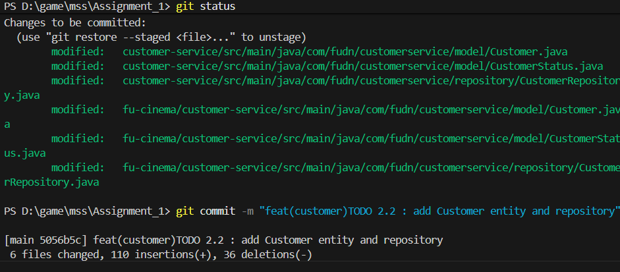

2.0 TODO 1.2-1.3

Commit : feat(customer): add bcrypt password encoder bean

feat(customer): add JwtService to sign HS256 access tokens

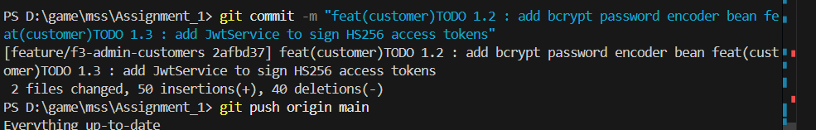

2.1 TODO 1.4

Commit : feat(customer): implement login for admin and customers`

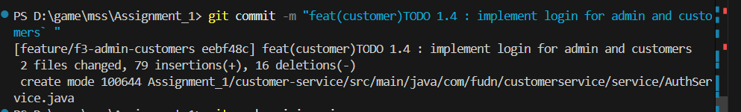

2.2 TODO 2.4 ,2.5,3.2

ToDo 2.4 feat(customer): implement customer registration with unique email

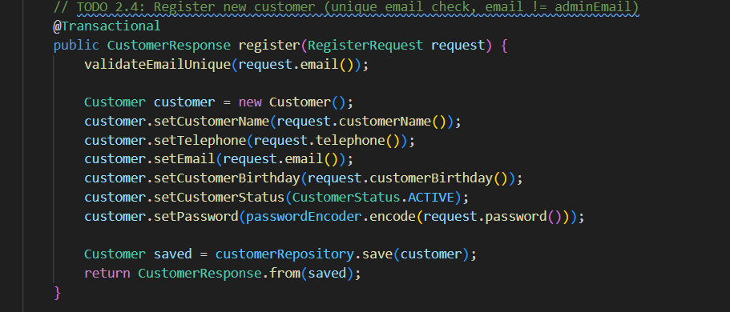

TODO 2.5 feat(customer): implement view, update profile and change password

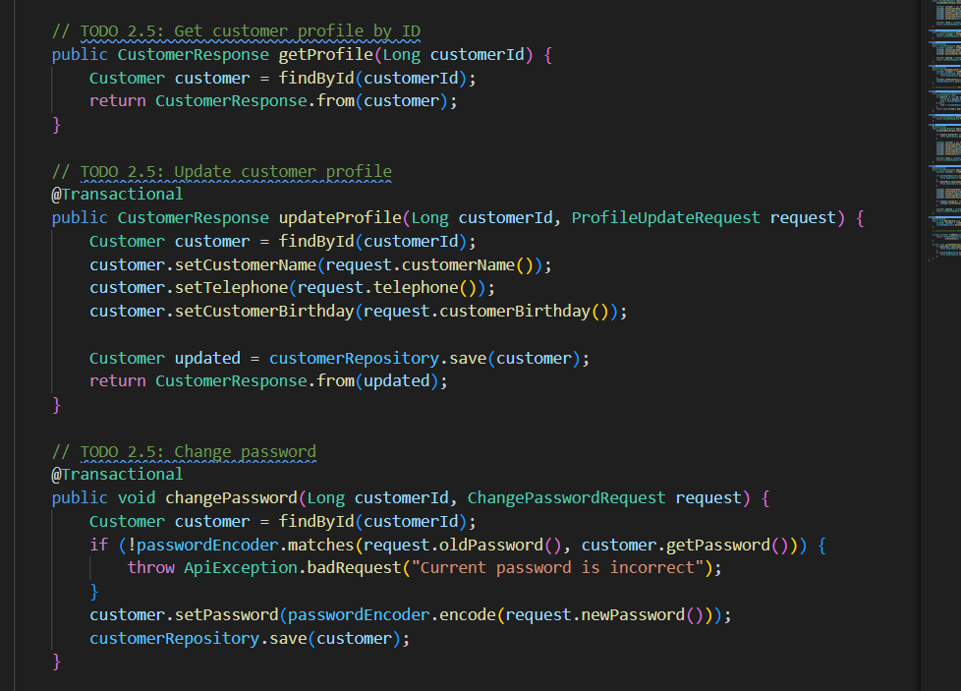

TODO 3.2 feat(customer): implement view, update profile and change password

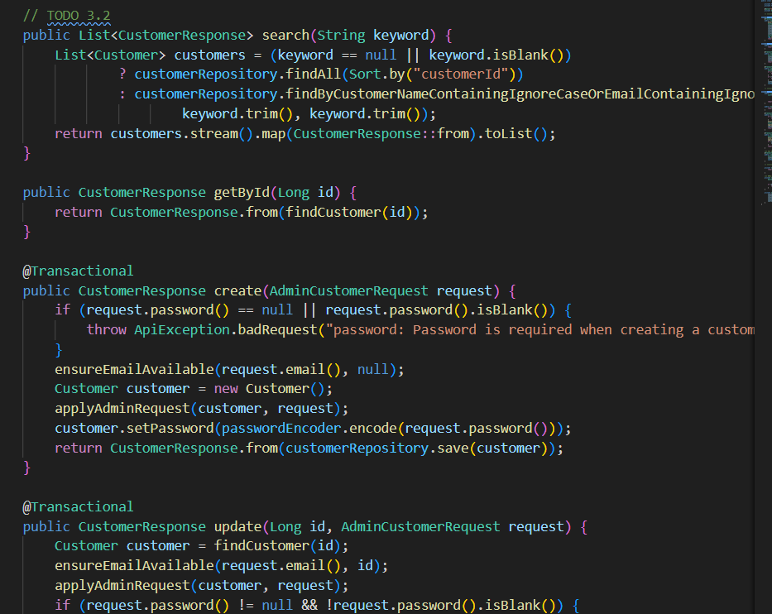

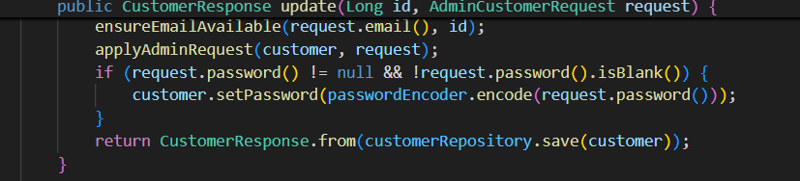

Commit : feat(customer): implement view, update profile and change password

feat(customer): implement customer registration with unique email

feat(customer): implement admin customer search and crud with soft delete

2.3 TODO 2.6 , 1.5 , 3.3

Commit :

feat(customer): expose register and /me endpoints

feat(customer): expose POST /api/auth/login

feat(customer): expose admin customer crud endpoints

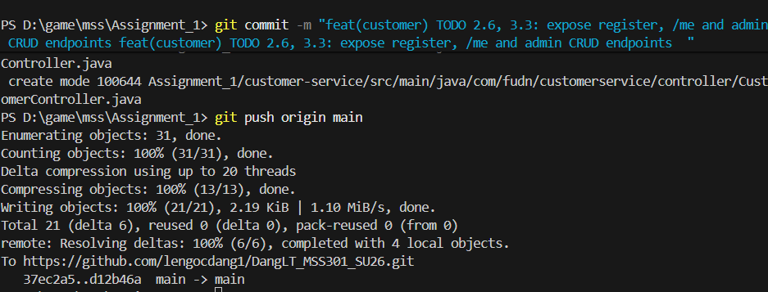

2.3 TODO 0.3

Commit : chore(movie) TODO 0.3 : initialize movie service spring boot project with mongodb dependency

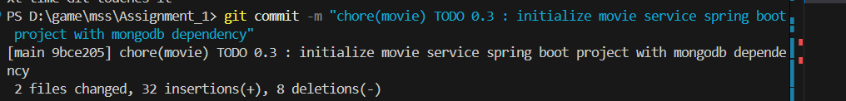

2.4 TODO0.5

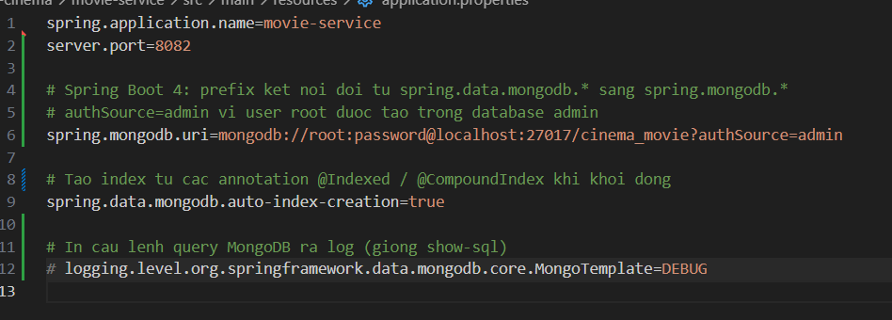Commit : chore(movie): configure mongodb connection uri and auto index creation

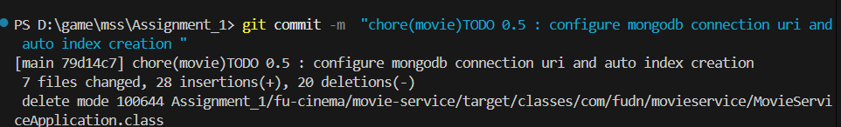

2.5 ToDo 4.2 , 5.1 , 6.1

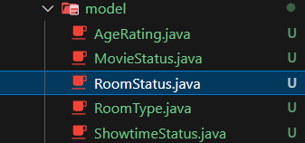

Commit : feat(movie): add Genre and CinemaRoom documents with unique indexes

feat(movie): add Movie document referencing genre id

feat(movie): add Showtime document with decimal128 price

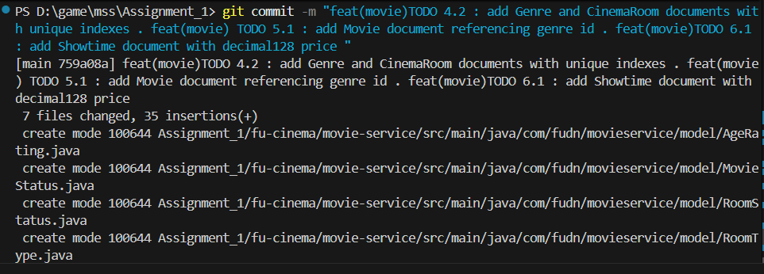

2.5 ToDo 4.2 , 5.2 , 6.2

Commit : feat(movie): add Genre and CinemaRoom documents with unique indexes

feat(movie): search movies with MongoTemplate criteria

feat(movie): add derived query counting overlapping showtimes

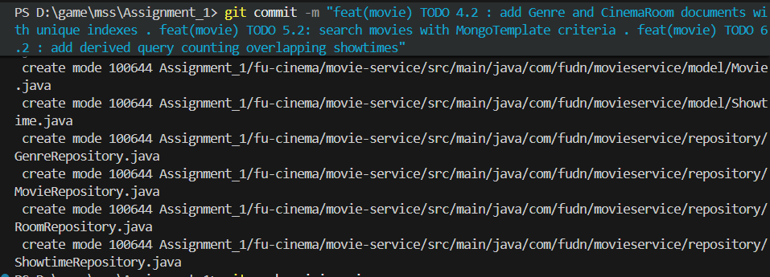

2.5 ToDo 4.3

Commit : feat(movie): implement genre and room services with delete guards

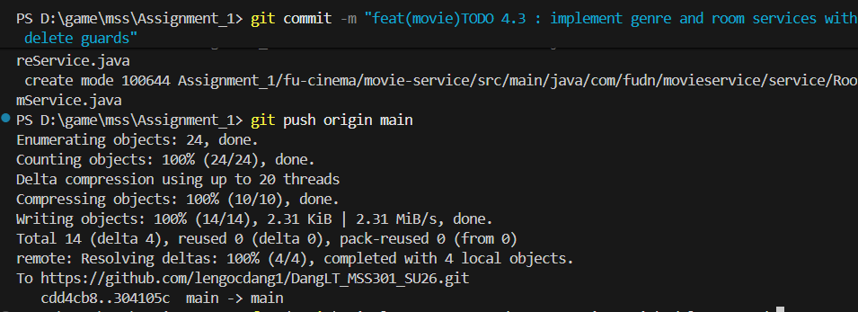

2.6 ToDo 5.2 , 5.3

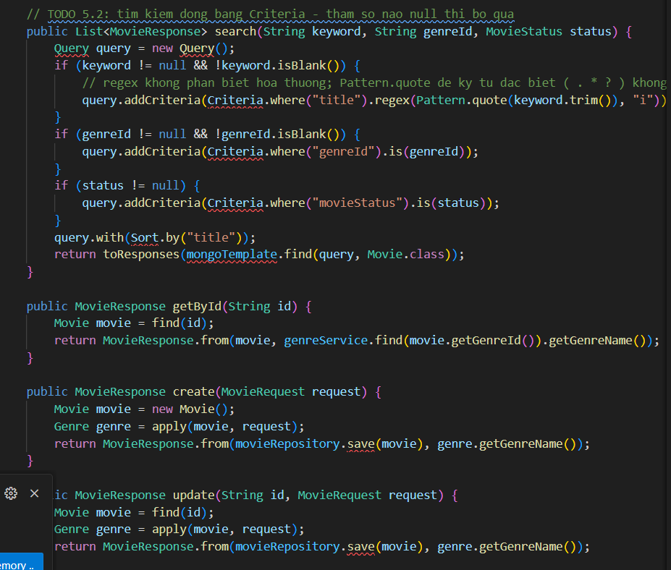

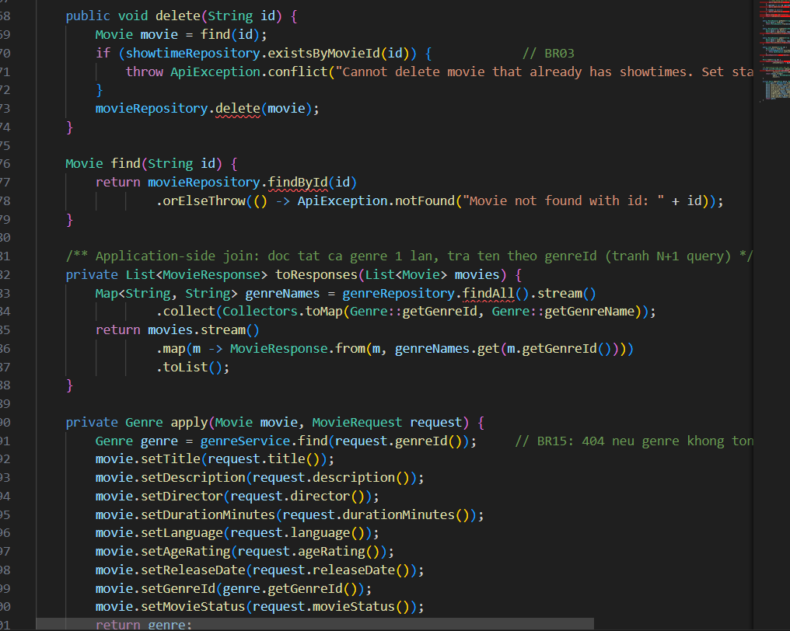

Commit : feat(movie): search movies with MongoTemplate criteria

feat(movie): implement movie crud with genre existence check

2.7 Todo 6.3 , 6.4

Todo 6.4

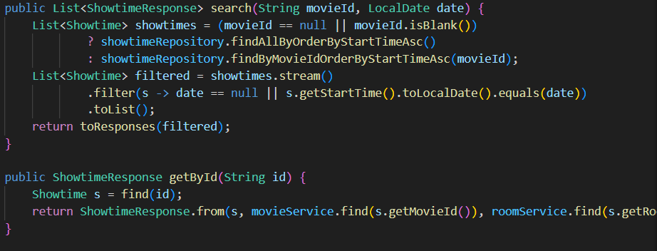

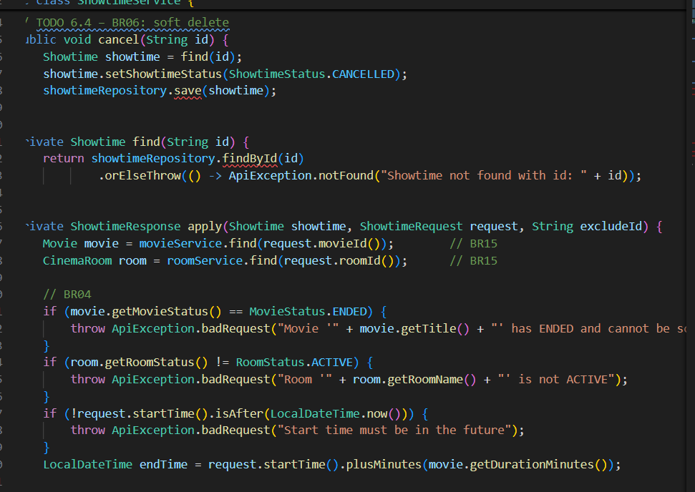

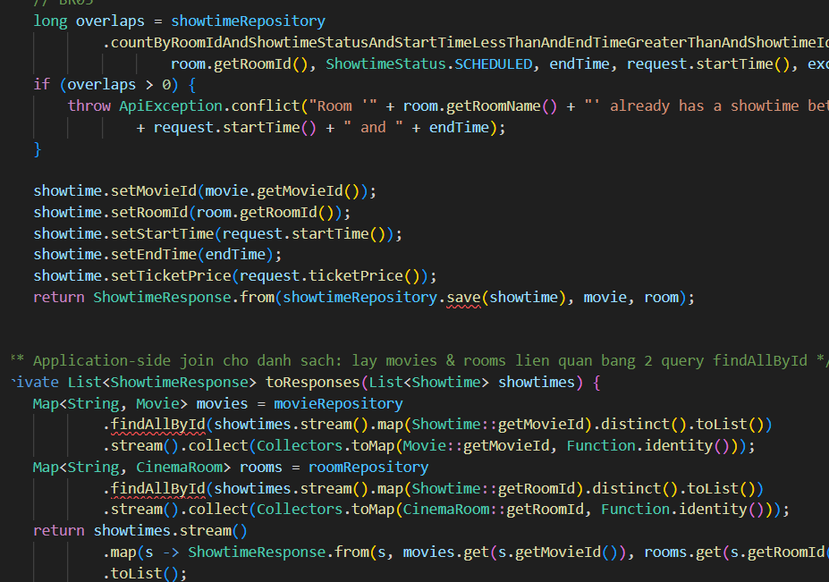

ToDo 6.3

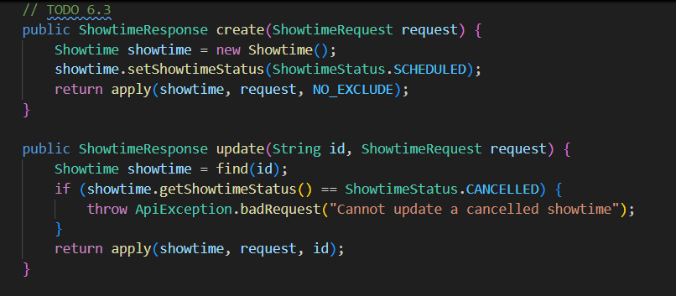

Commit : feat(movie): validate and schedule showtimes with computed end time

feat(movie): implement showtime cancel and search by movie and date

Todo 2.8

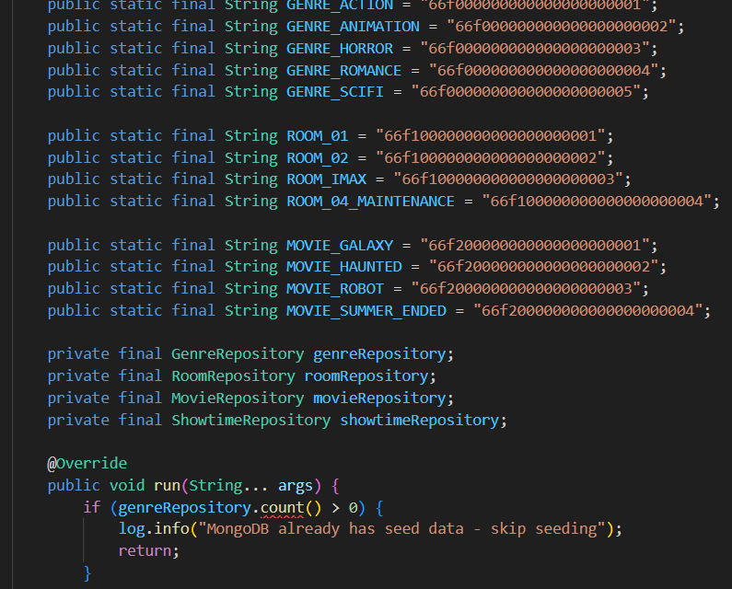

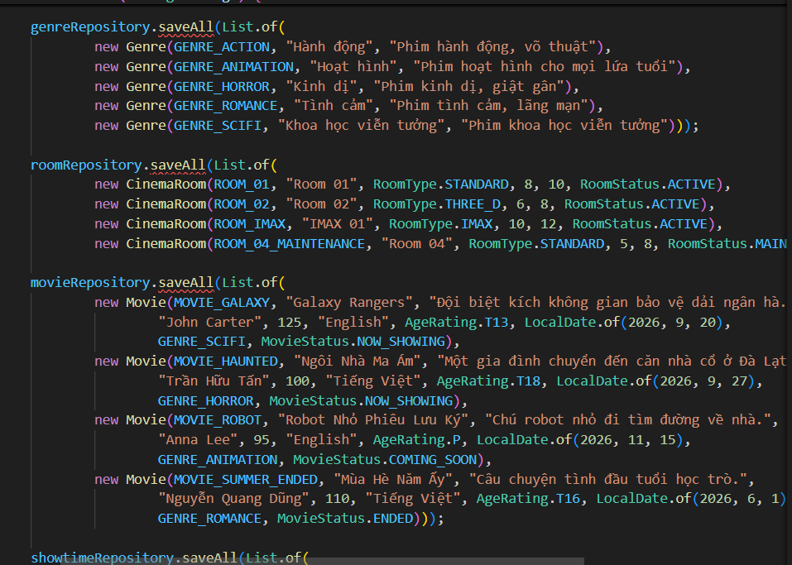

Commit :feat(movie): implement showtime cancel and search by movie and date

2.9 Todo 4.4 ,5.4 ,6.5

Commit :feat(movie): expose genre and room endpoints

feat(movie): expose movie endpoint

feat(movie): expose showtime endpoints

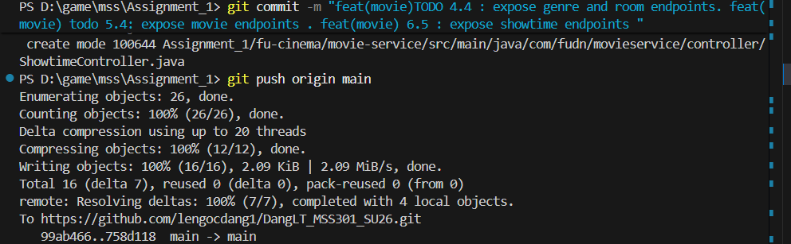

3.0 Todo 3.12

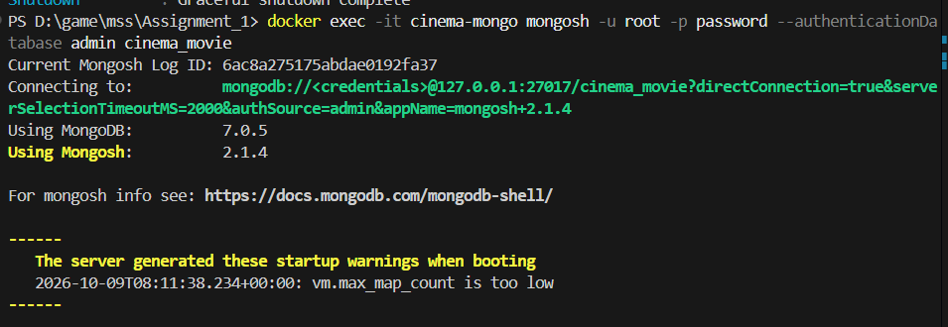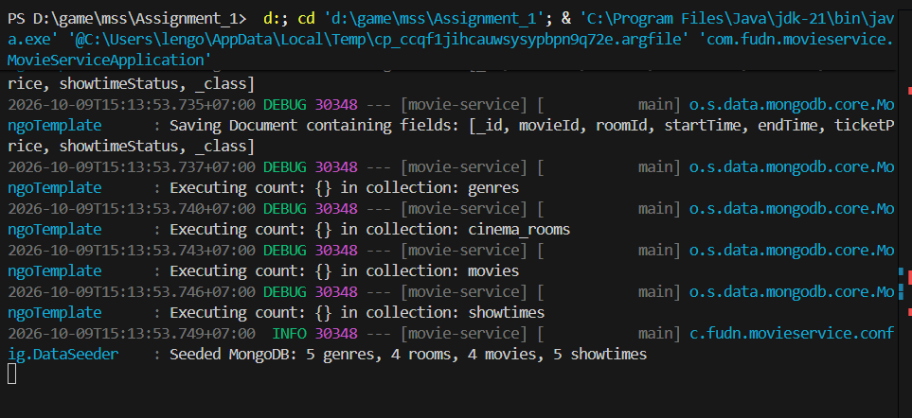

Commit : (feat) fix and Movie service

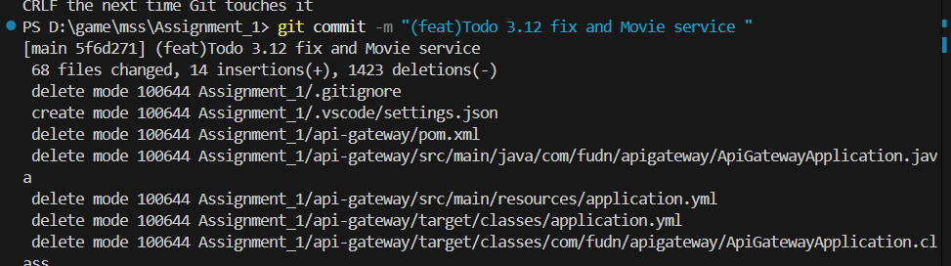

3.1 Todo 0.3 - 7.1

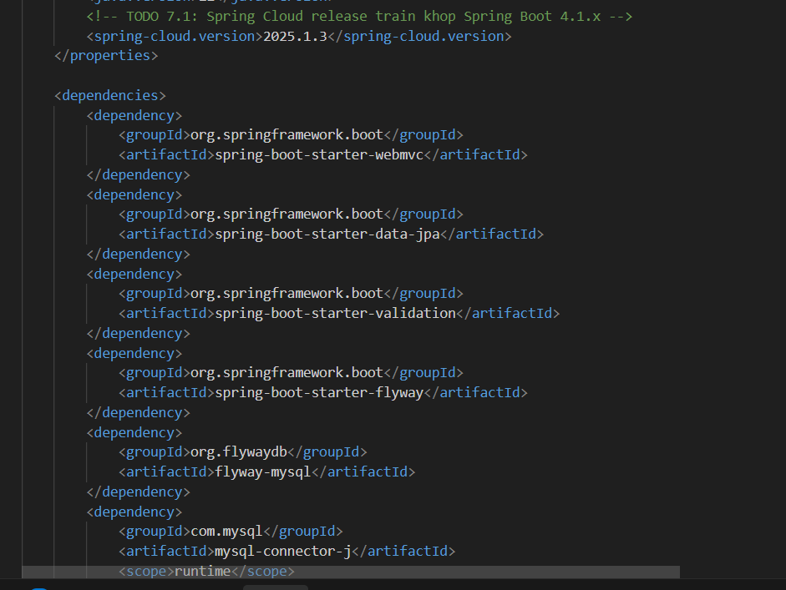

Commit :

build(booking): add openfeign and spring cloud bom

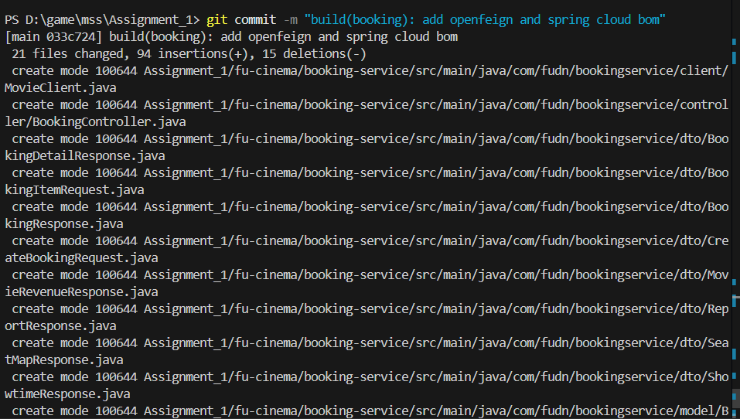

3.1 Todo 7.2

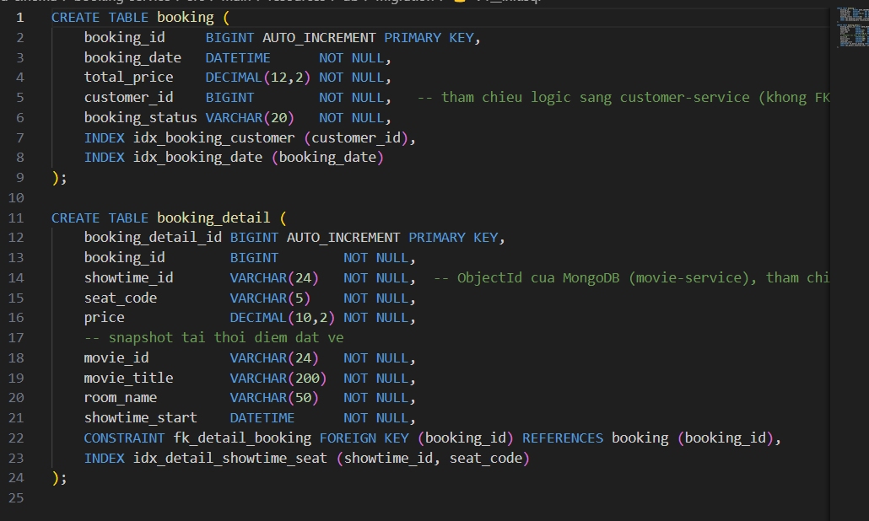

Commit : feat(booking): add mysql migration with varchar object id columns

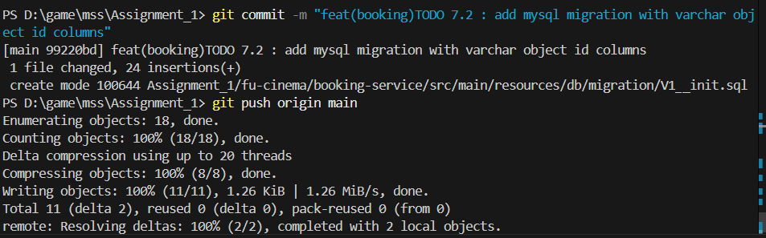

3.1 Todo 7.3

Commit : feat(booking): add Booking and BookingDetail entities

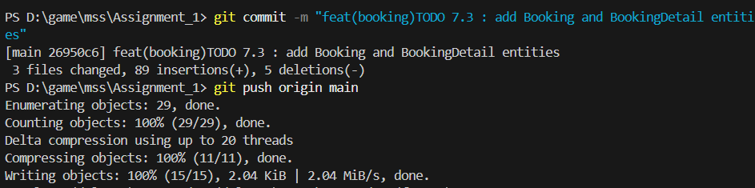

3.2 Todo 9.1

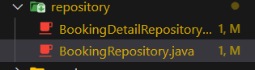

Commit :feat(booking): add report query by booking date range

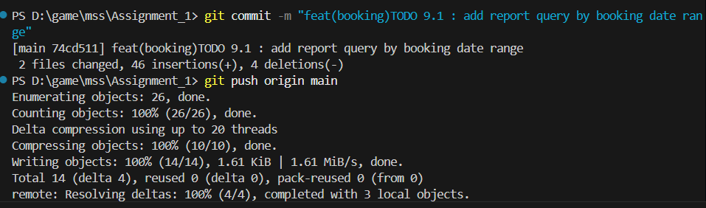

3.3 Todo 7.4

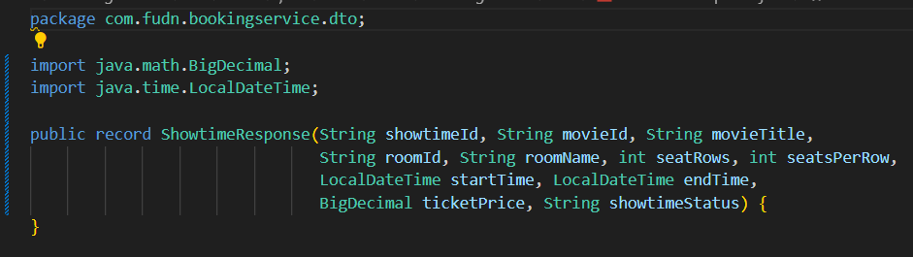

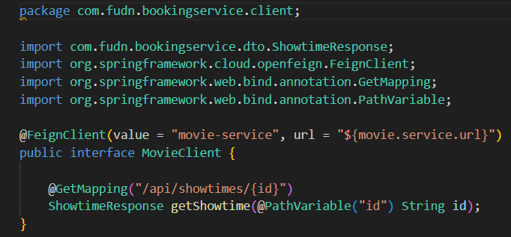

Commit : feat(booking): add MovieClient feign client with string showtime I

3.2 todo 4.10

3.3 todo 0.4

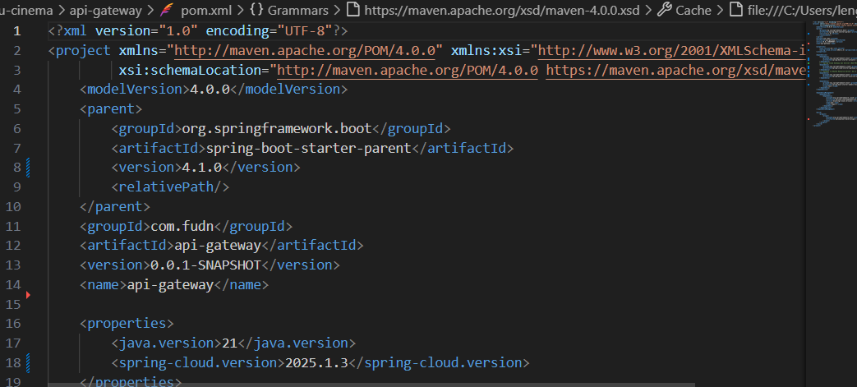

Commit: (feat) Todo 0.3 Generate project & `pom.xml

3.4 todo 10.1

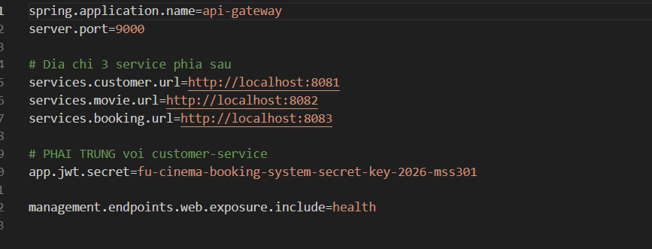Commit :chore(gateway): configure service urls and jwt secret

3.5 todo 10.2

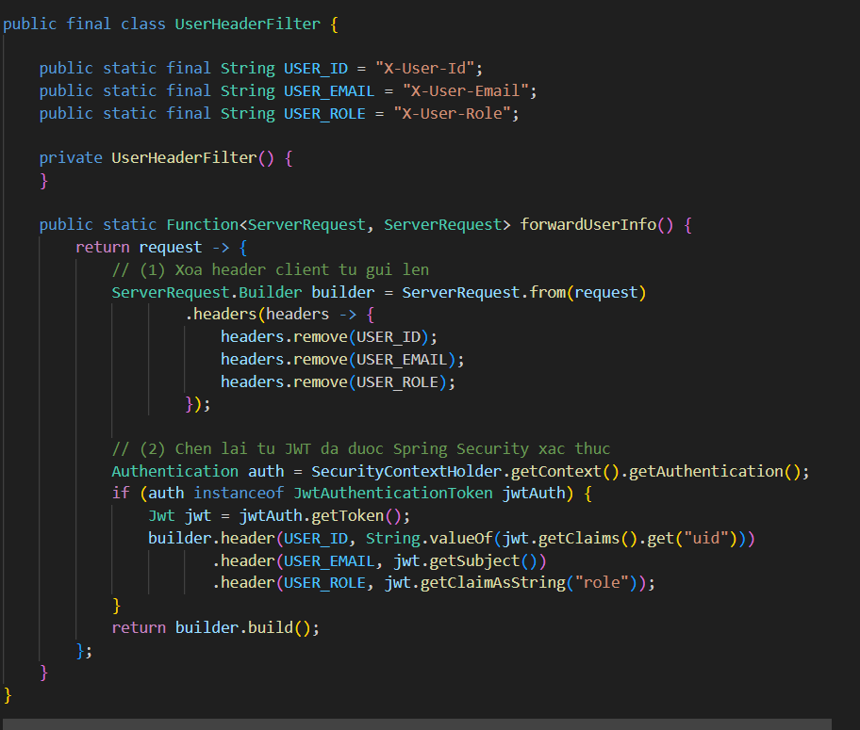

Commit :feat(gateway): forward user context headers from jw

3.6 Todo 10.3

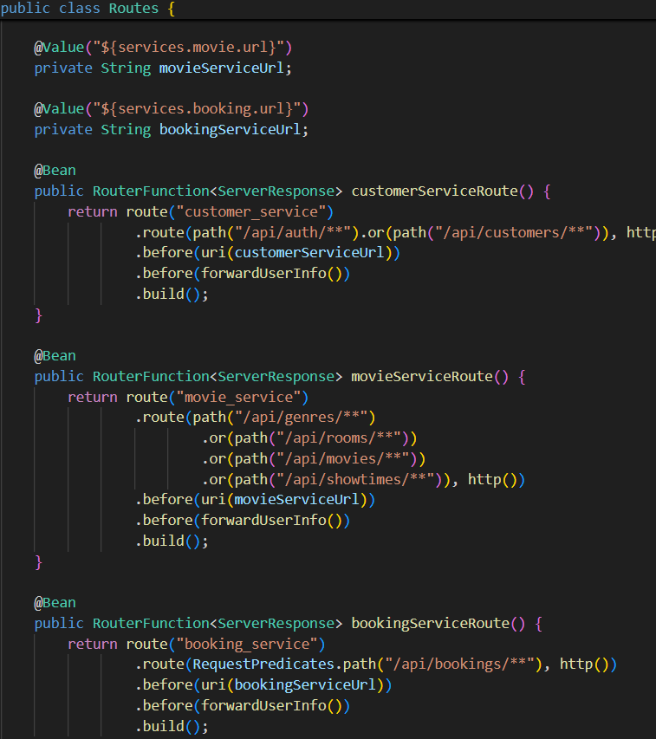

Commit : feat(gateway): add routes for customer, movie and booking services

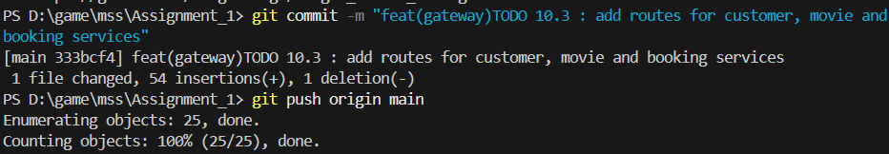

3.7 TODO 10.4

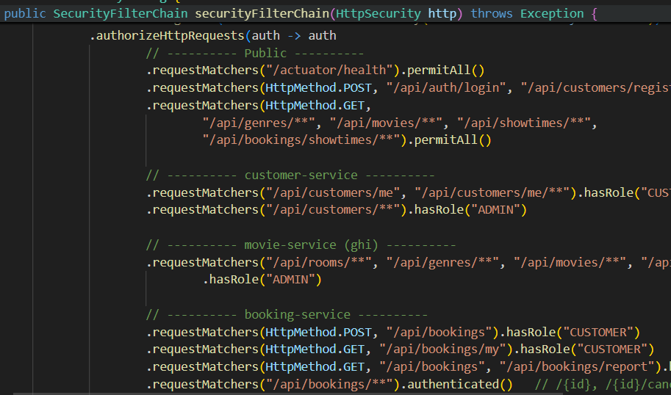

Commit : feat(gateway): secure endpoints with jwt and role-based rule

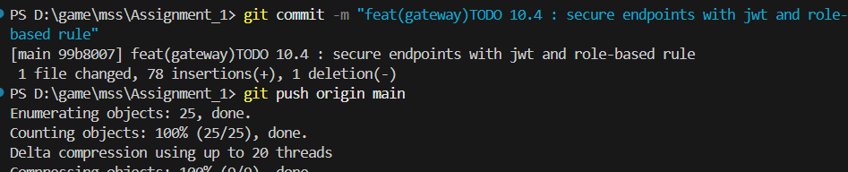

3.8

3.9

curl http://localhost:9000/actuator/health # {"status":"UP"}

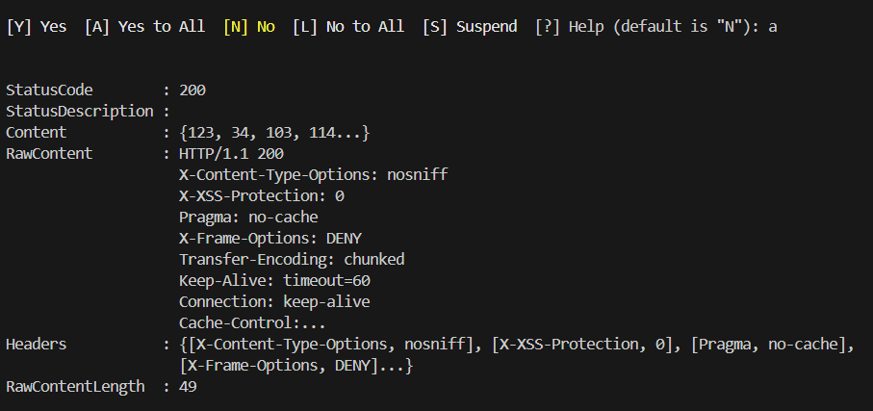

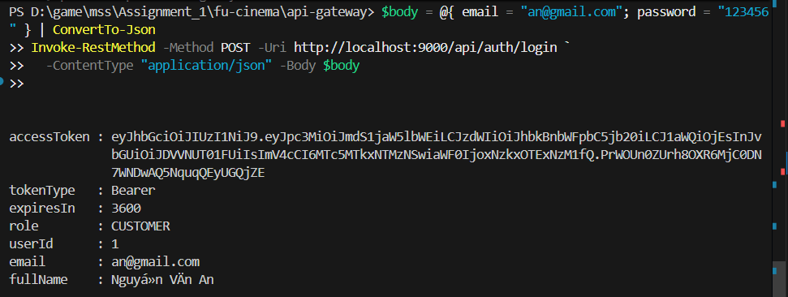

4.0 Bước 6 – Chạy toàn hệ thống

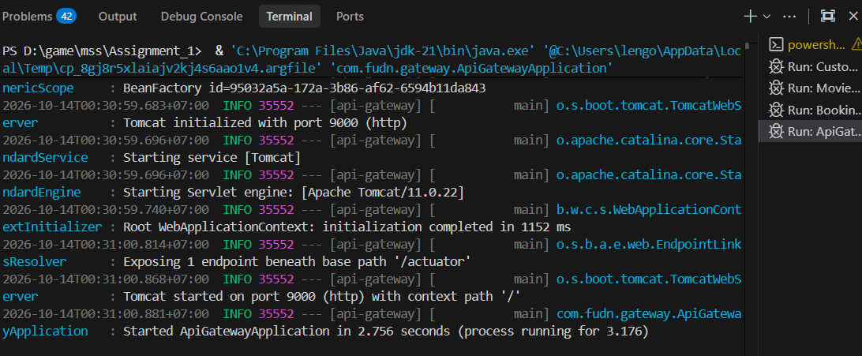

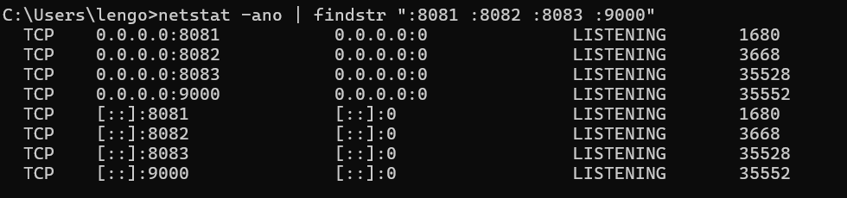

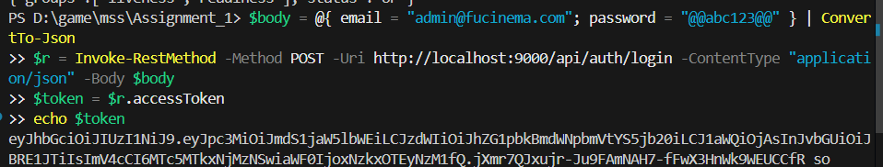

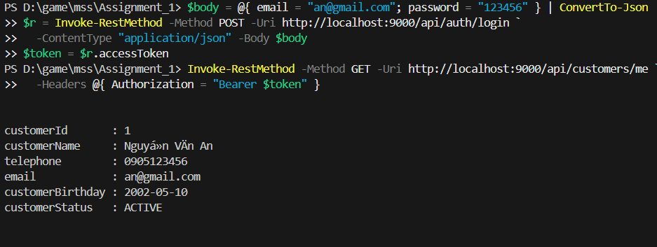

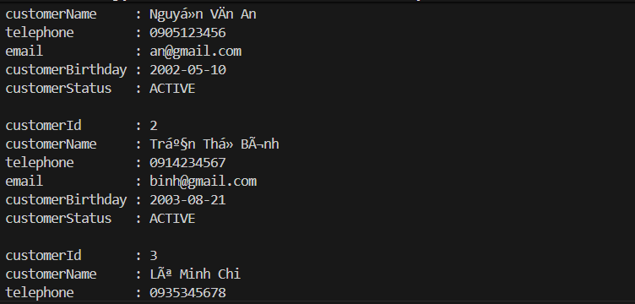

Mỗi mục sẽ gồm kết quả chạy, commit message

F1- Authentication (customer-service + Gateway)

TODO 2.1 Flyway V1__init.sql (bảng customer) + V2__seed.sql (3 customer mẫu, 1 INACTIVE)

Tiếp tục các phần F11 – Kiểm thử Postman.
1-Auth
- 1 Login Admin
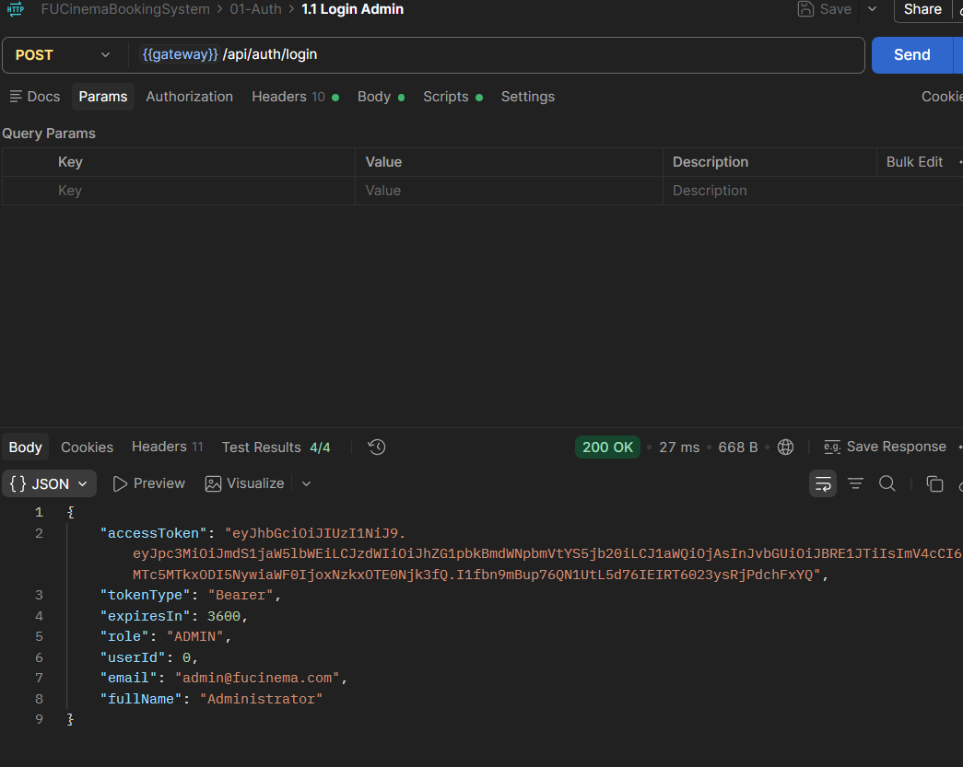
1.2 Login Customer
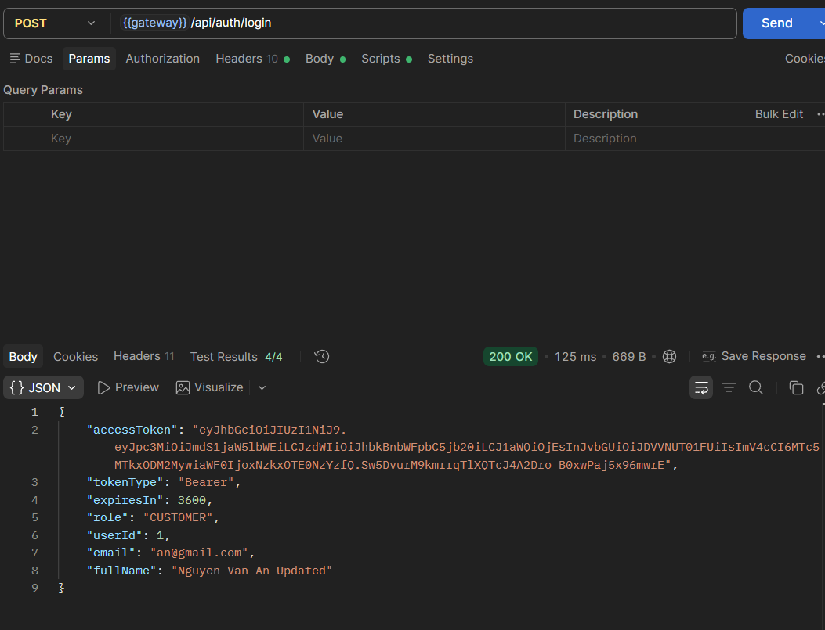
1.3 Login - sai mật khẩu - 403
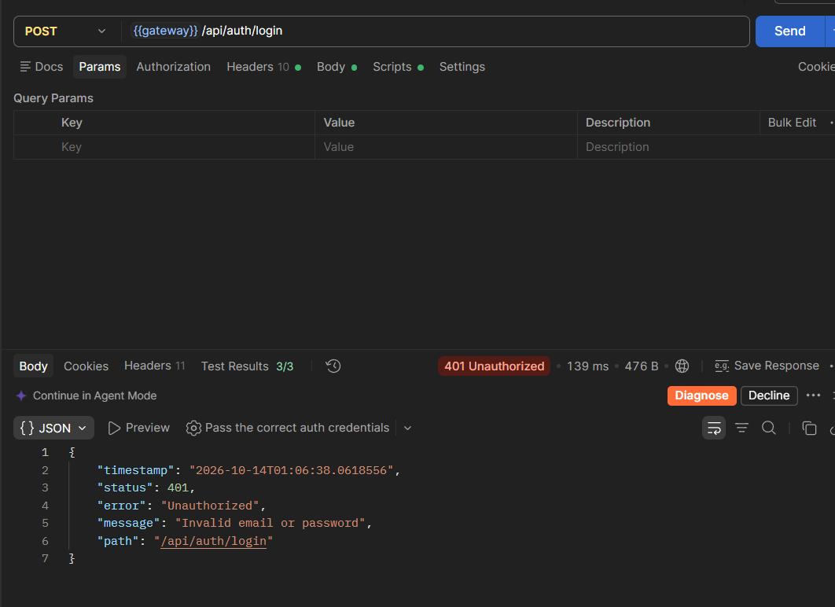
1.4 Login - sai mật khẩu - 401
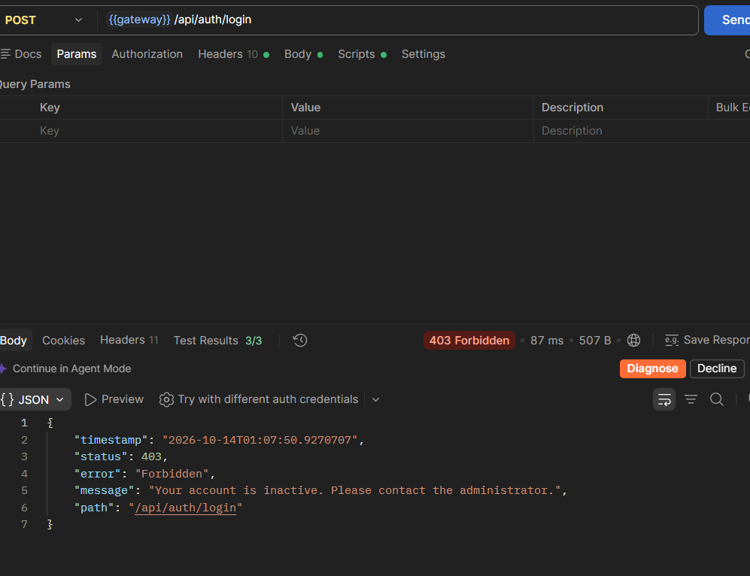
1.5 Login - validation error
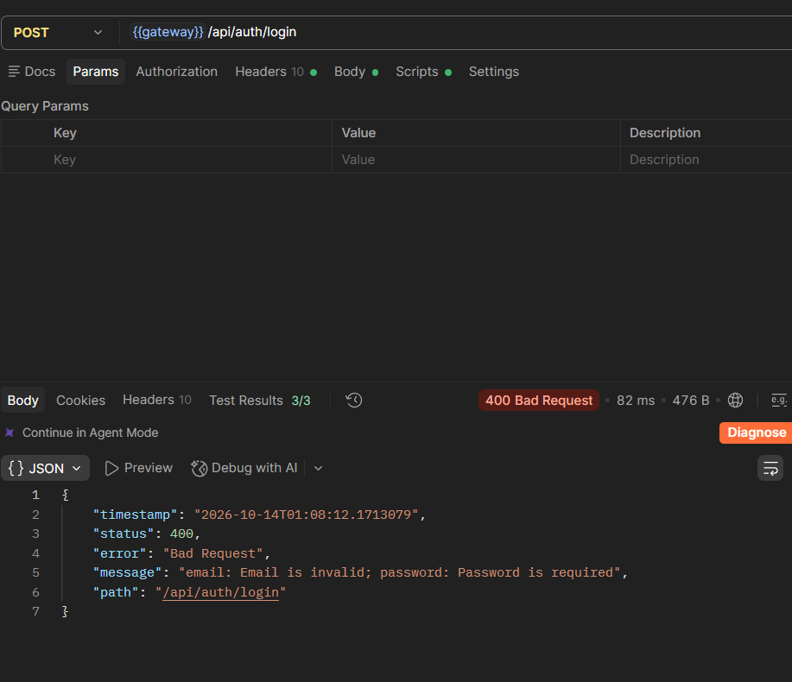
1.6 get/customers/me - không token - 401
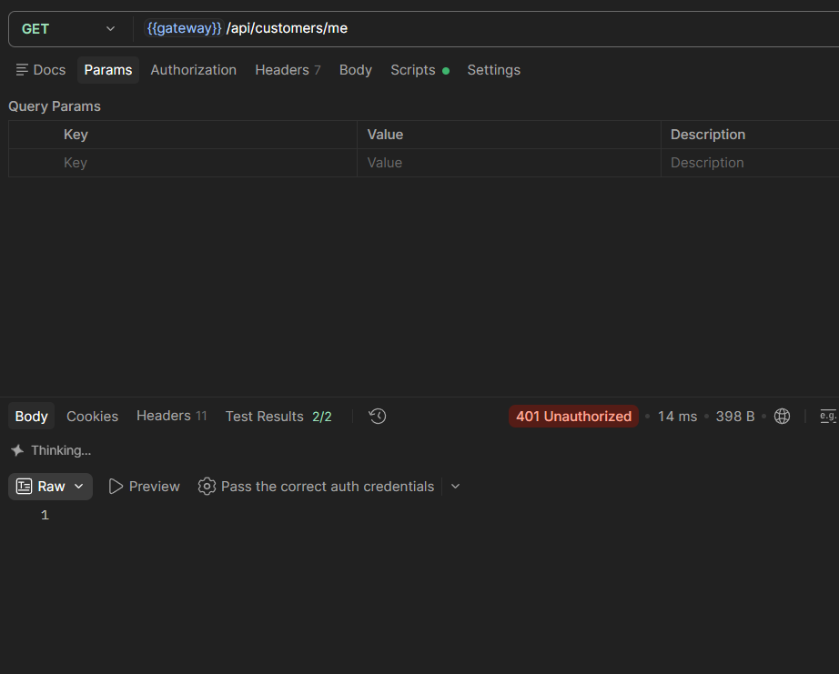
1.7 get/customers/me token sai
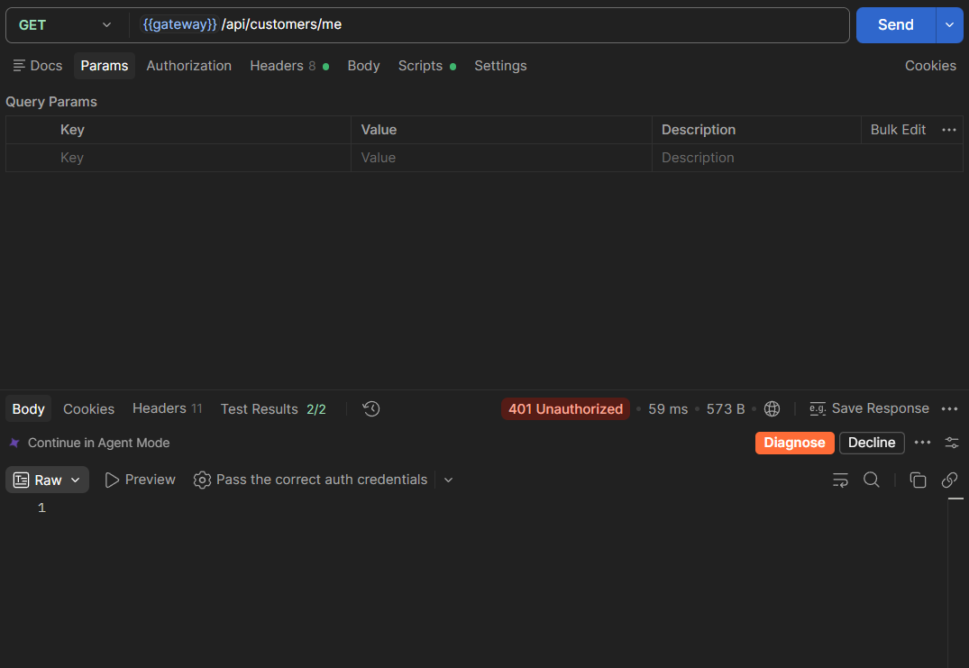
2 Customer
2.1 Register new customer
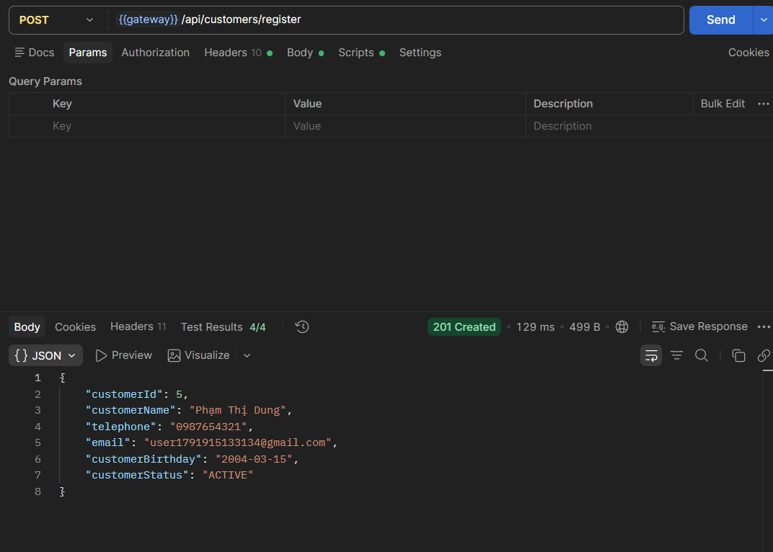
2.2 Register – email trùng → 409
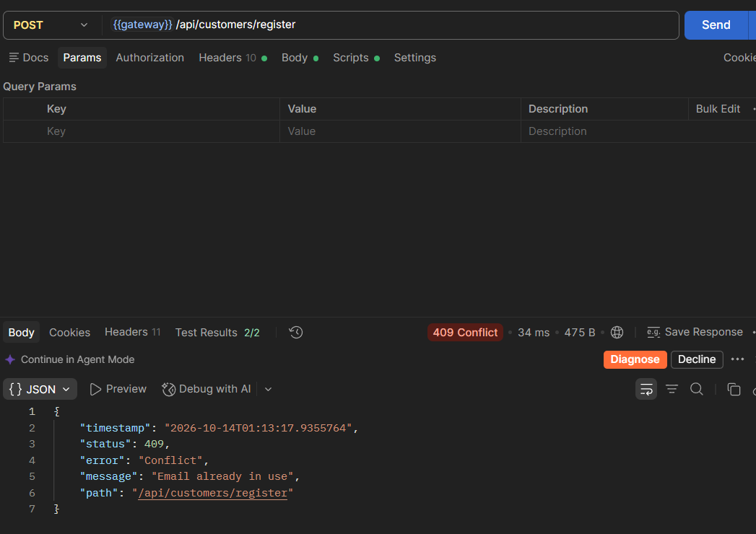
2.3 Register – validation nhiều lỗi → 400
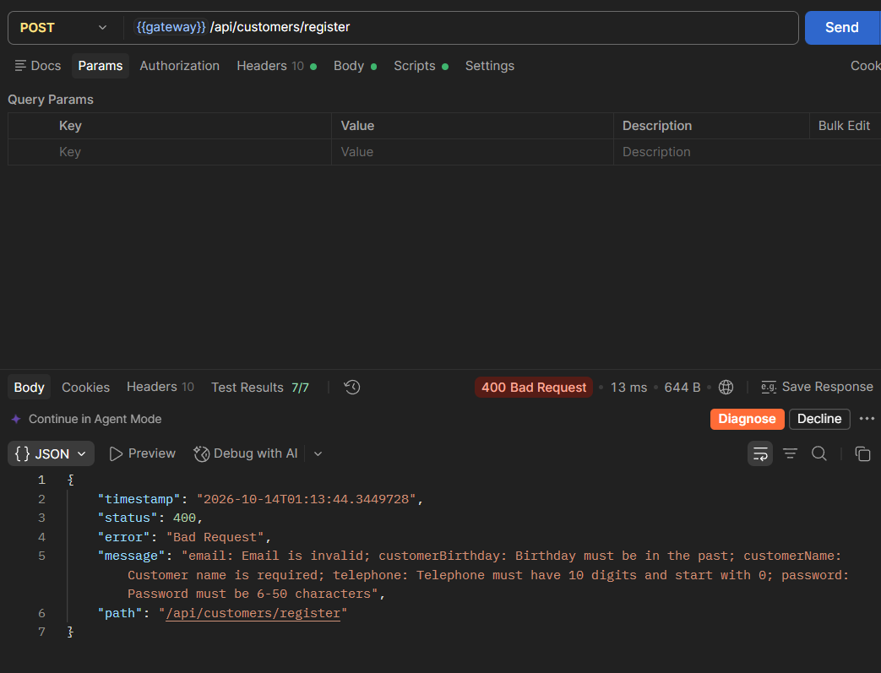
2.4 Login customer mới → lưu customer2Token
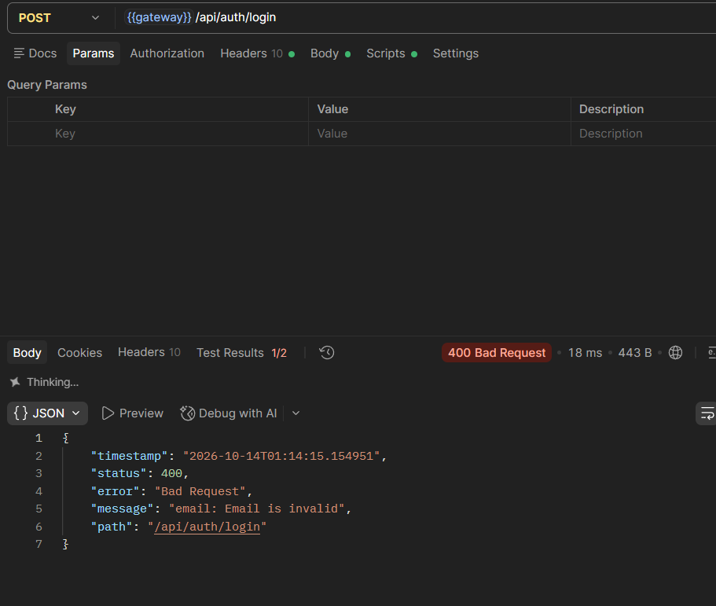
2.5 GET /customers/me (customerToken)
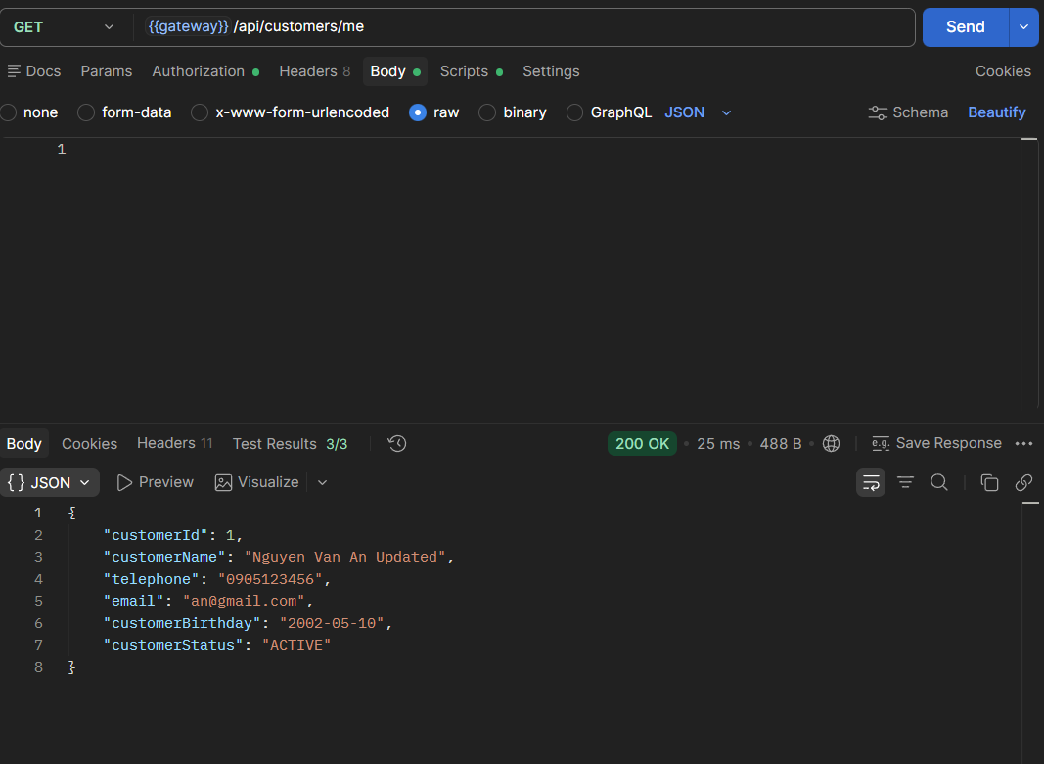
2.6 PUT /customers/me – update profile
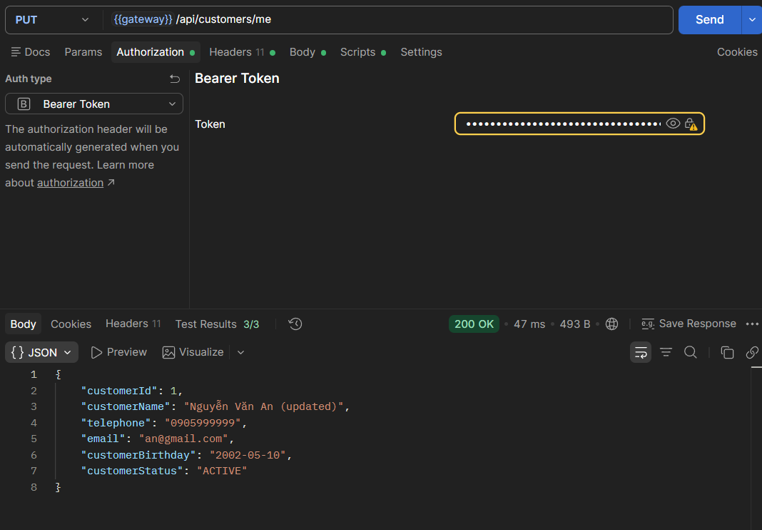
2.7 PUT /customers/me/password – sai oldPassword → 400
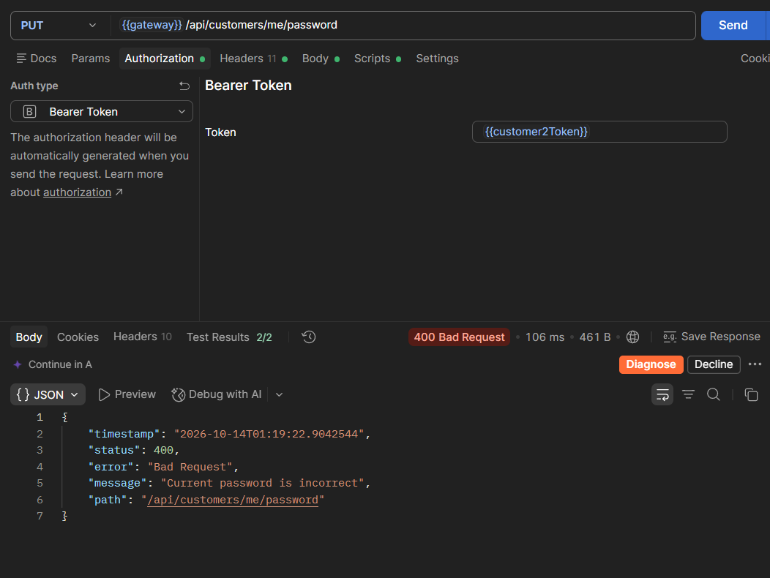
2.8 PUT /customers/me/password – đổi thành công → 204
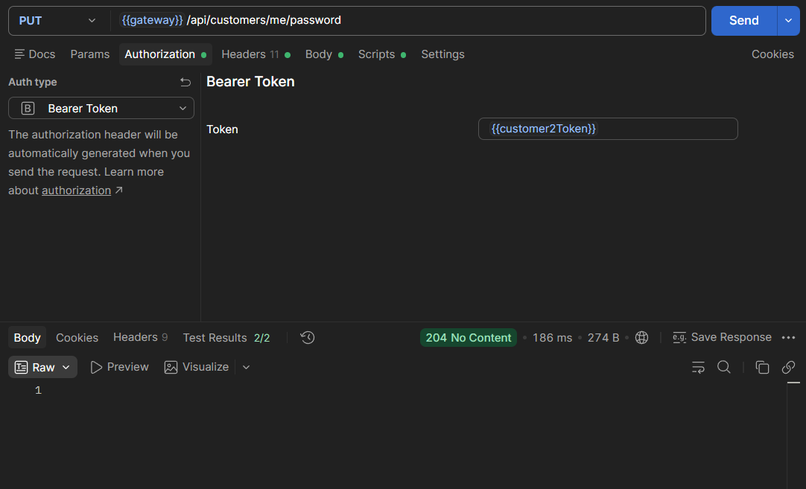
2.9 Login customer2 với pass mới → cập nhật customer2Token
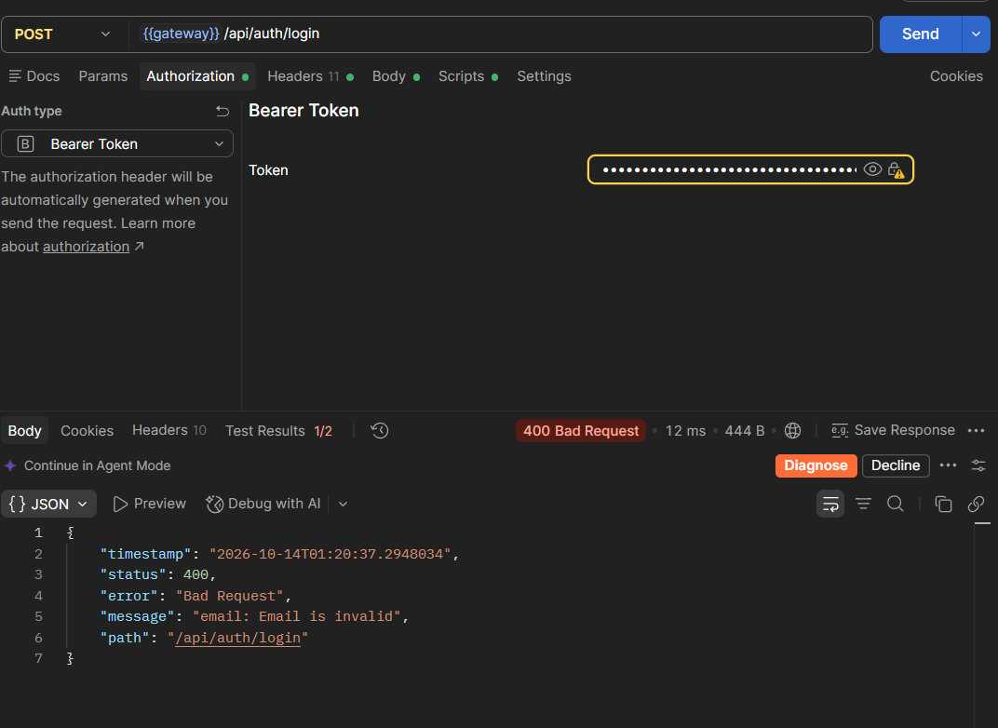
2.10 GET /customers – Customer → 403

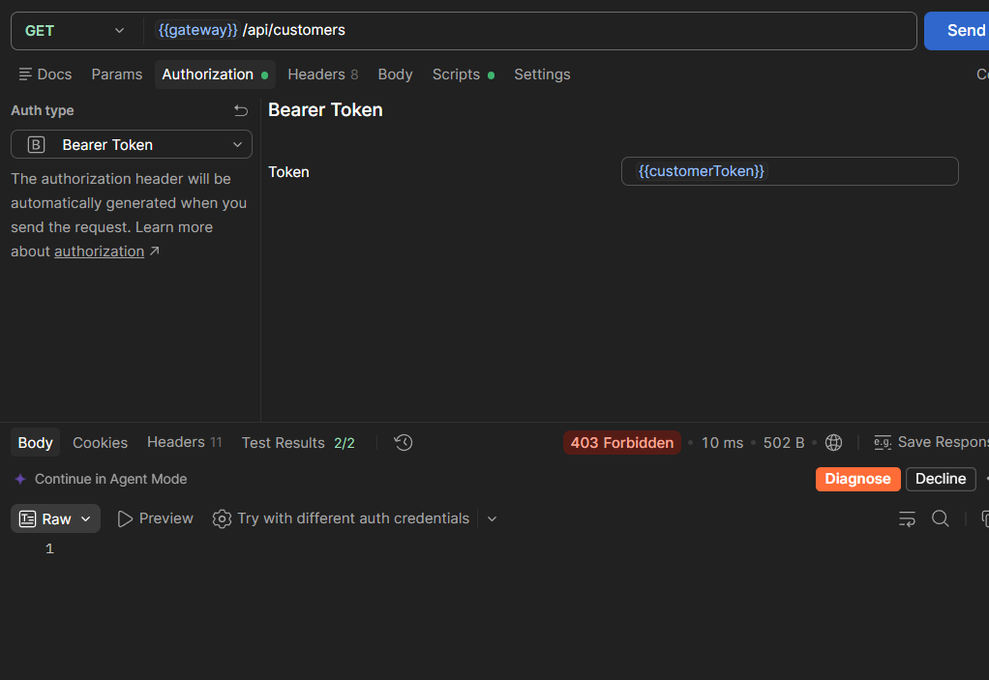
2.11 GET /customers?keyword=gmail (Admin) → ≥3
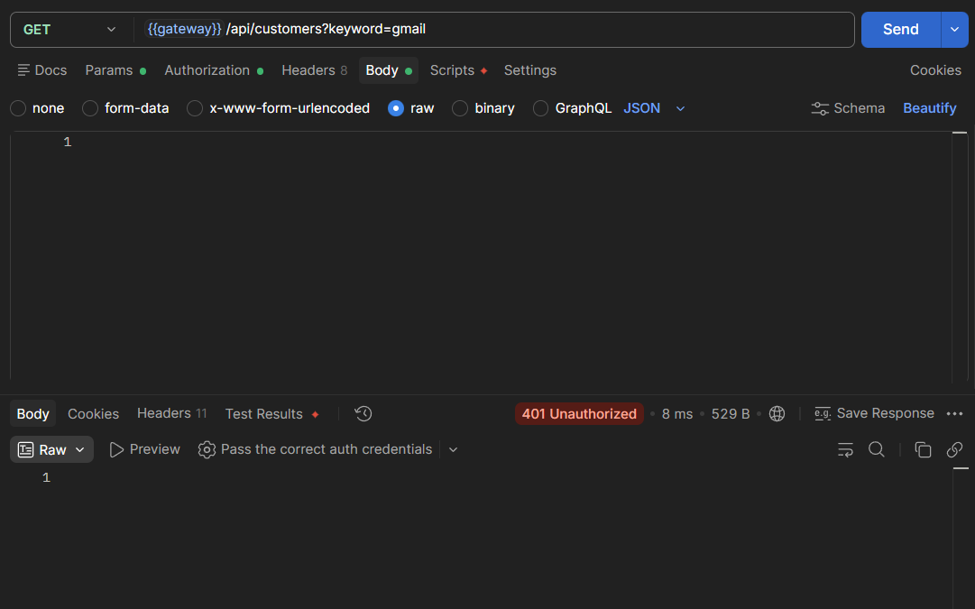
2.12 GET /customers/99999 → 404
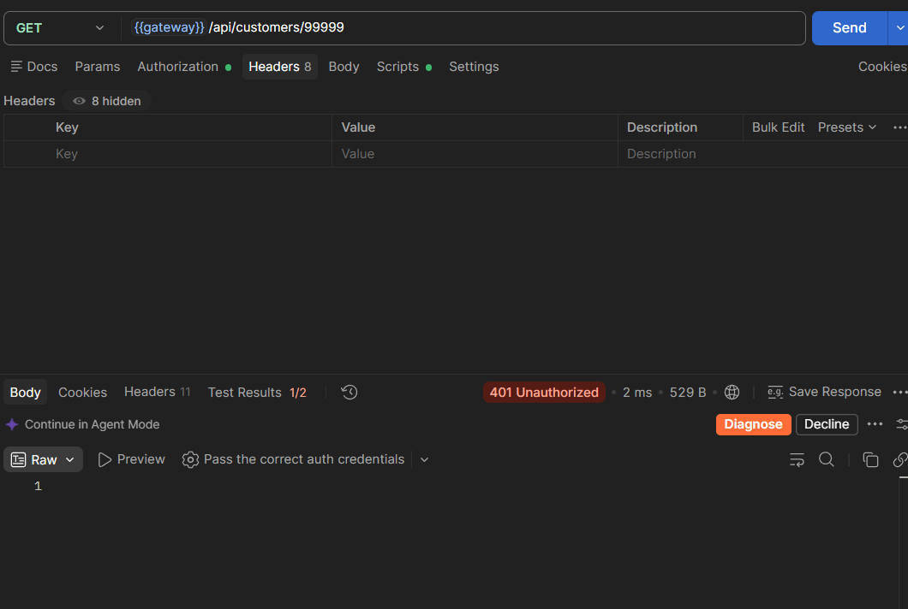
2.13 POST /customers (Admin create)
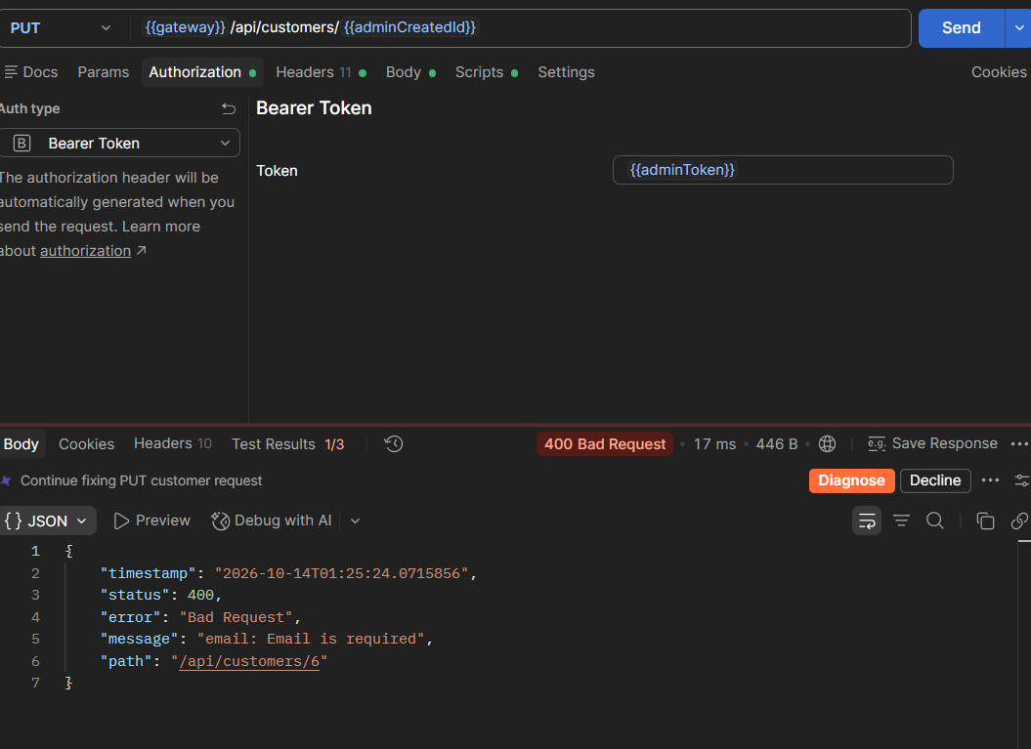
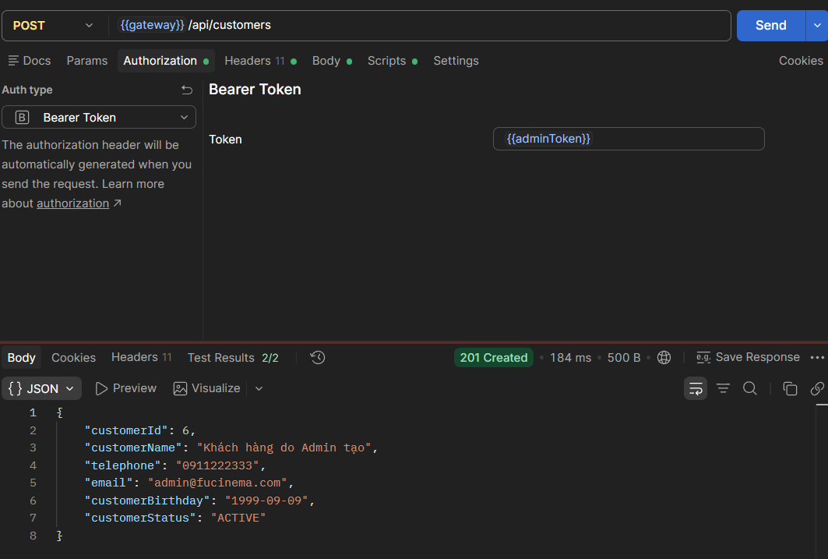
2.15 DELETE /customers/{{adminCreatedId}} → 204
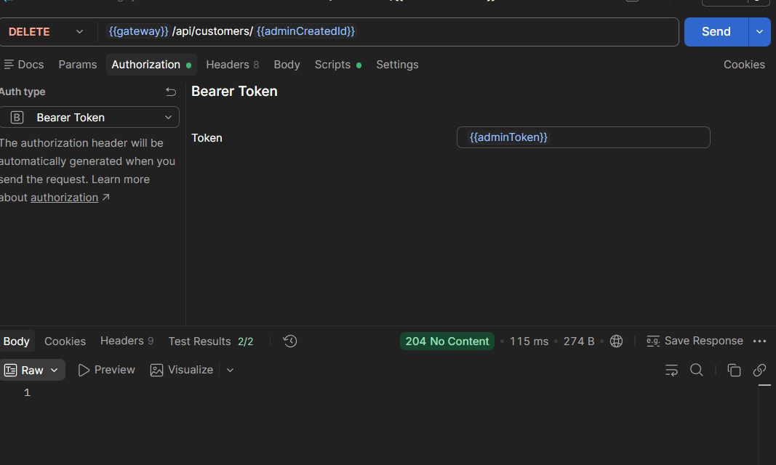
2.16 GET /customers/{{adminCreatedId}} → INACTIVE
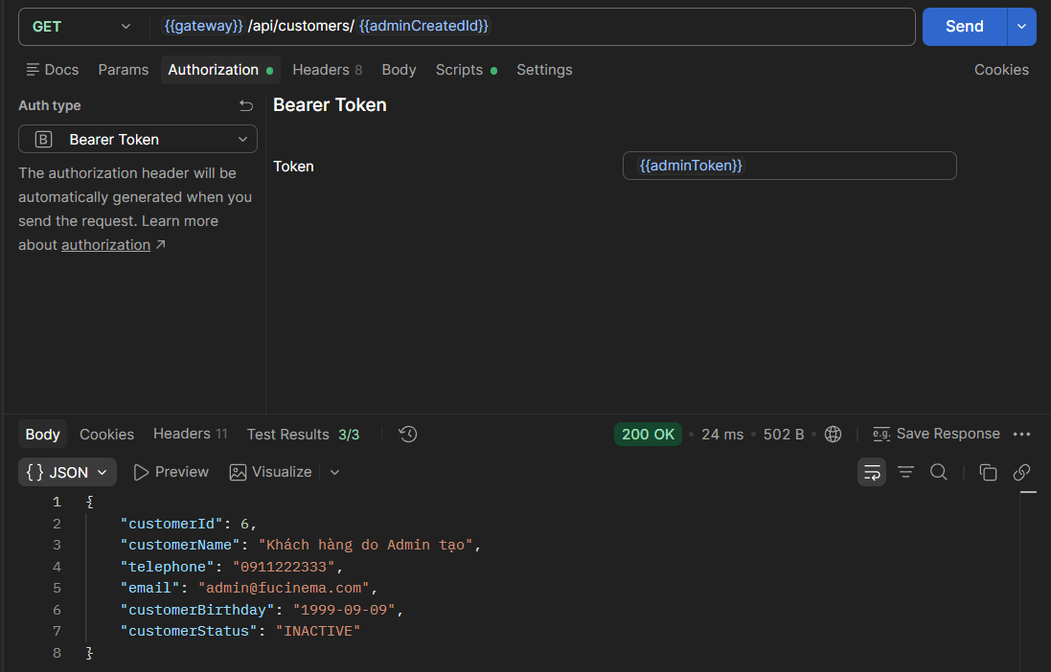

2.17 GET /customers/me (adminToken) → 403
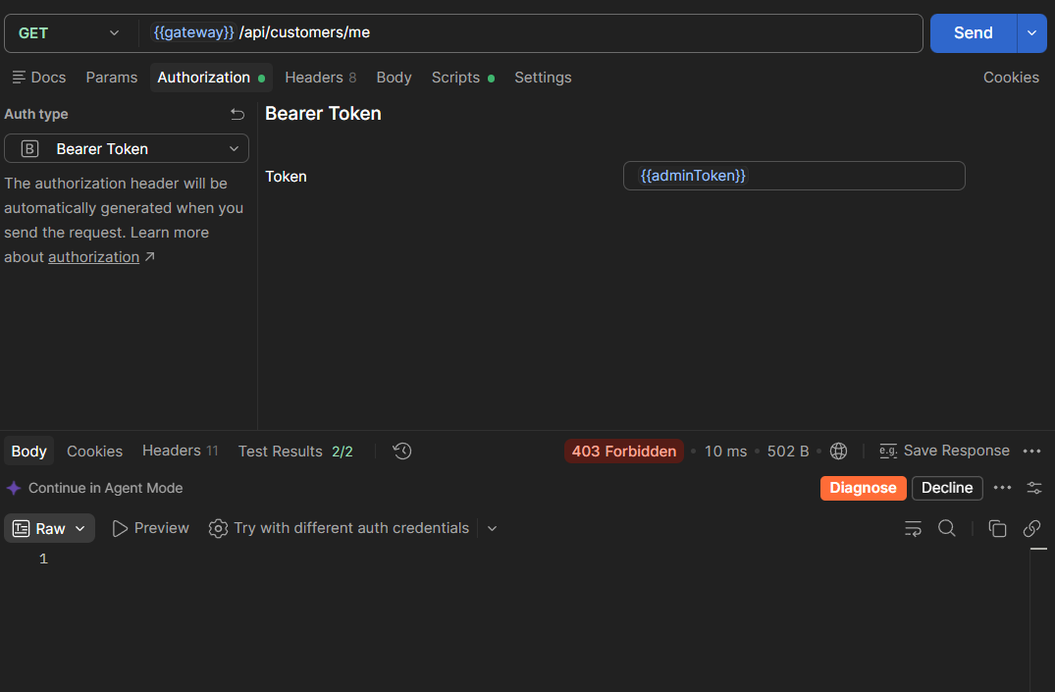
2.18 GET /customers/me – Gateway ghi đè X-User-Id giả
